Ergonomic machine operation
B&R swing arm systems with IP65-rated panels raise the bar
B&R is proud to present a brand new line of swing arm systems. These fully enclosed panels are available in a wide range of variants and feature IP65 protection, allowing them to be placed optimally on machines.
Multi-touch widescreen panels are available in sizes ranging from 18.5" to 24" with either HD Ready or Full HD resolution. The larger displays and higher resolution make it possible to include even more information on each screen – an enormous advantage for user ergonomics.
High definition in portrait format
If space is limited yet large displays are still necessary, a 21.5" model in portrait format is also available. With optional side handles, it is easy to maneuver and operate these devices at the machine. Two system variants with analog resistive touch screens are also available in 4:3 format, allowing users to upgrade their operator hardware without having to modify their existing HMI applications in any way.
Simple cabling
These panels are connected using affordable standard cables run conveniently through the swing arm shaft – even after mounting. And for those who choose Smart Display Link 3 – which allows up to 100 meters between the PC and panel – the slim RJ45 connector makes cabling even easier.
Easy operation
These swing arm systems can be equipped with buttons, selector switches, key switches and an integrated E-stop button as needed. Thanks to an integrated RFID reader, individual access rights can be assigned to anyone from service engineers to system operators. Jotting down passwords on small scraps of paper has been relegated to the past – right where it belongs.

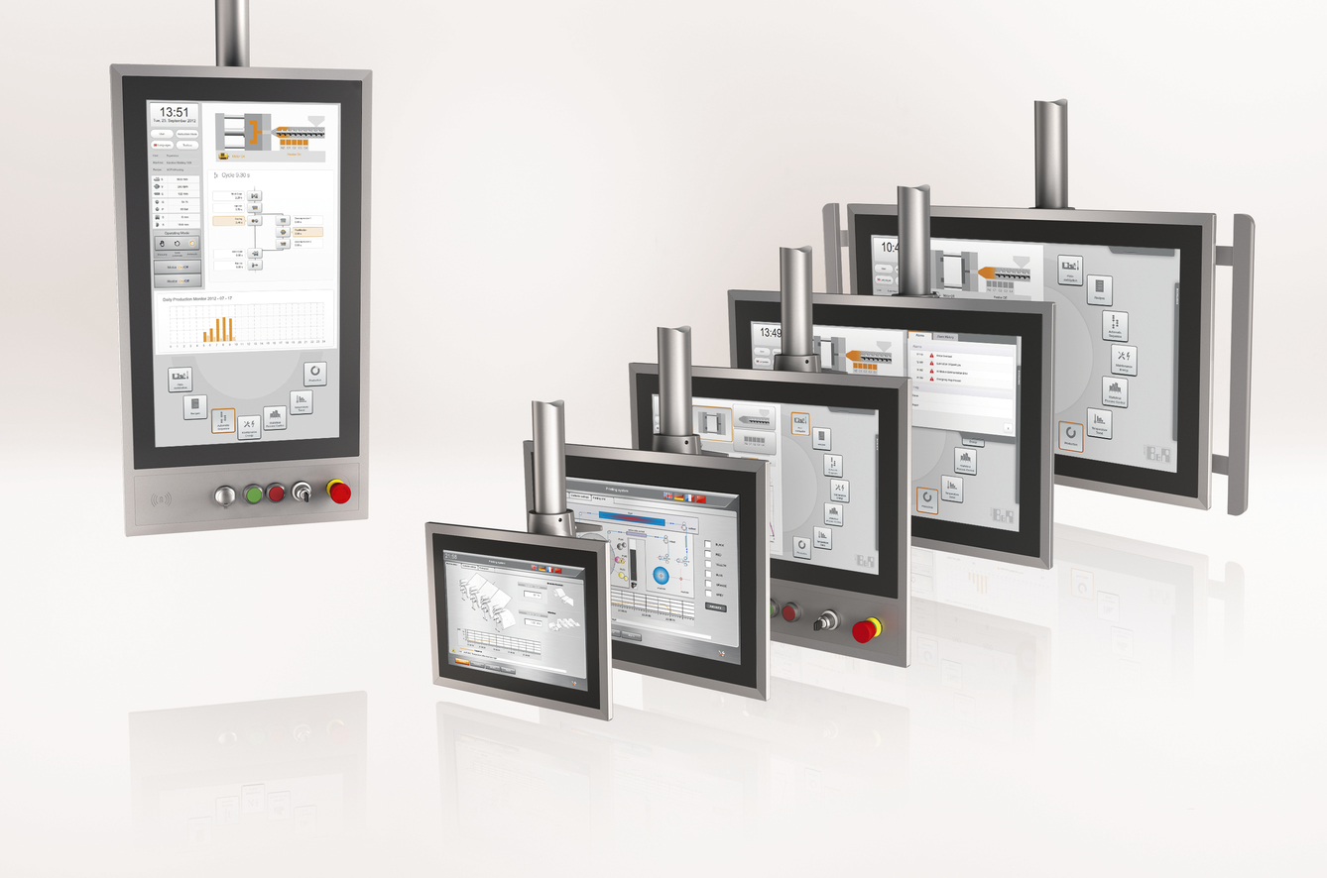
Displays from the Automation Panel series are available in nine different swing arm models and can be equipped with additional switching elements as needed.

About B&R
B&R, a division of ABB Group, is a global leader in industrial automation headquartered in Austria. B&R combines state-of-the-art technology with advanced engineering to provide customers in virtually every industry with complete solutions for machine and factory automation, motion control, HMI and integrated safety technology. With Industrial IoT communication standards including OPC UA, POWERLINK and openSAFETY as well as its Automation Studio software, B&R is constantly redefining the future of automation engineering. The innovative spirit that keeps B&R at the forefront of industrial automation is driven by a commitment to simplifying processes and exceeding customer expectations.
For more information, visit www.br-automation.com.

