One cable for everything
No more hard wiring with openSAFETY control panels
New openSAFETY operator panels from B&R allow safe data exchange over the bus system. The integrated openSAFETY interface renders the hard wiring of E-stop, operating mode and start buttons obsolete.
Simple cabling of swing arm systems
Settings up operator panels with several hard-wired switches and buttons by threading countless cables up through the swing arm system is nothing but a headache. openSAFETY operator panels, on the other hand, only require a bus and power connection. This means that these systems can be placed exactly where they are needed without having to deal with unwieldy cable harnesses. Commissioning and service are also simplified, saving additional money in these areas as well. The E-stop button is just as reliable as its hard-wired counterparts.
Arrange buttons and switches as needed
These operator panels are available in a wide range of configurations, allowing them to be tailored perfectly to any application. In addition to different display sizes and ratios, it is also possible to choose between various touch technologies. Just as configurable are the number and arrangement of buttons, switches and the E-stop button. The operator panels are also available in housings rated up to IP65. And to round it off, B&R can customize these devices for specific clients and offer solutions for specific industries, such as food and beverages.

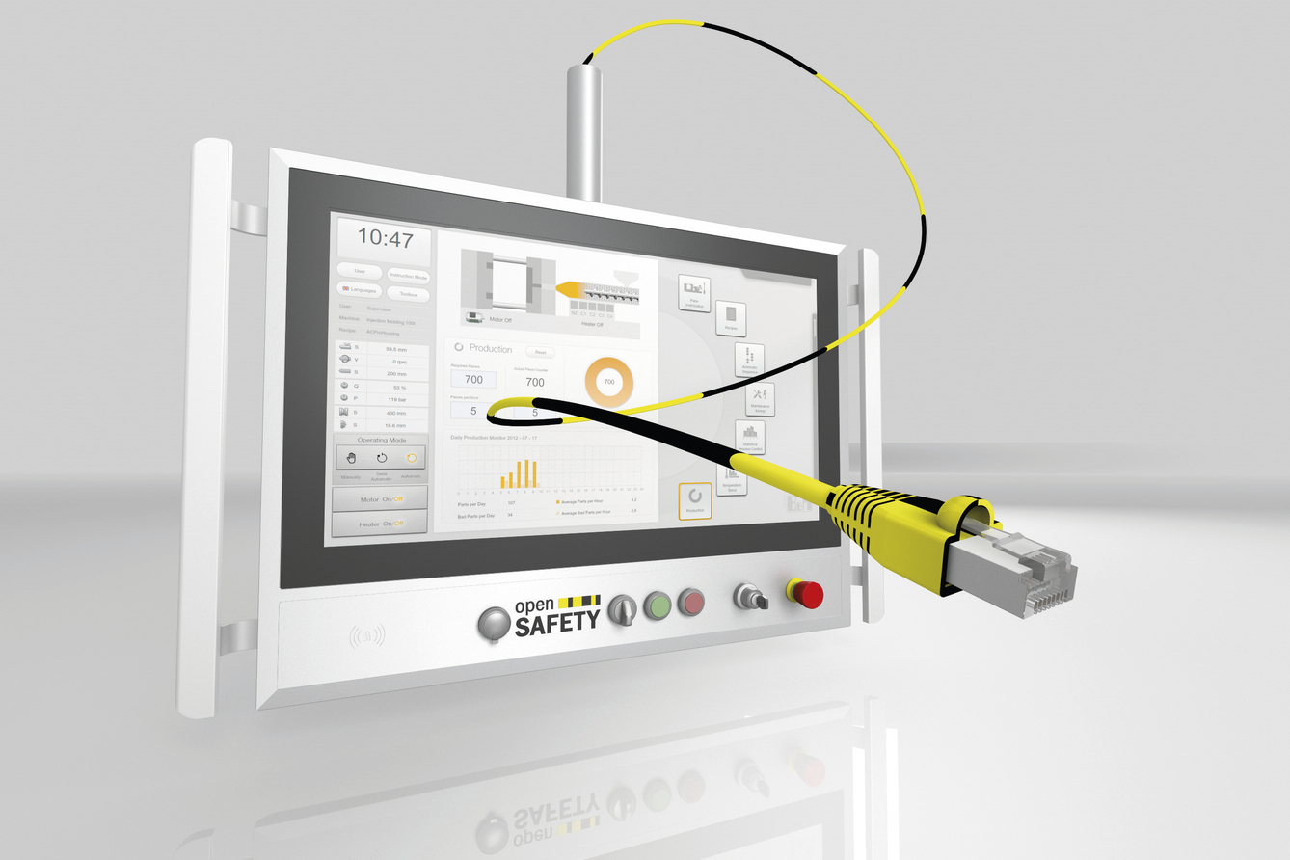
openSAFETY control panels from B&R allow safety data to be transferred via the bus system.

About B&R
B&R, a division of ABB Group, is a global leader in industrial automation headquartered in Austria. B&R combines state-of-the-art technology with advanced engineering to provide customers in virtually every industry with complete solutions for machine and factory automation, motion control, HMI and integrated safety technology. With Industrial IoT communication standards including OPC UA, POWERLINK and openSAFETY as well as its Automation Studio software, B&R is constantly redefining the future of automation engineering. The innovative spirit that keeps B&R at the forefront of industrial automation is driven by a commitment to simplifying processes and exceeding customer expectations.
For more information, visit www.br-automation.com.

