One cable for everything
No more hard wiring with openSAFETY control panels
New openSAFETY operator panels from B&R allow safe data exchange over the bus system. The integrated openSAFETY interface renders the hard wiring of E-stop, operating mode and start buttons obsolete.
Simple cabling of swing arm systems
Settings up operator panels with several hard-wired switches and buttons by threading countless cables up through the swing arm system is nothing but a headache. openSAFETY operator panels, on the other hand, only require a bus and power connection. This means that these systems can be placed exactly where they are needed without having to deal with unwieldy cable harnesses. Commissioning and service are also simplified, saving additional money in these areas as well. The E-stop button is just as reliable as its hard-wired counterparts.
Arrange buttons and switches as needed
These operator panels are available in a wide range of configurations, allowing them to be tailored perfectly to any application. In addition to different display sizes and ratios, it is also possible to choose between various touch technologies. Just as configurable are the number and arrangement of buttons, switches and the E-stop button. The operator panels are also available in housings rated up to IP65. And to round it off, B&R can customize these devices for specific clients and offer solutions for specific industries, such as food and beverages.

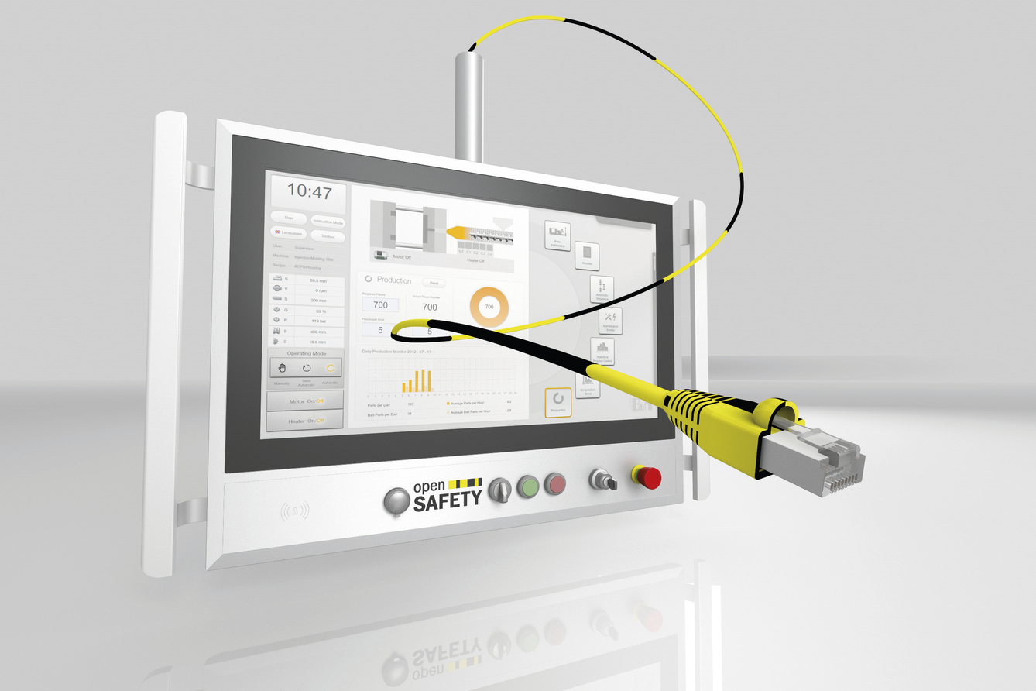
openSAFETY control panels from B&R allow safety data to be transferred via the bus system.

B&R Hakkında
ABB Grubunun bir bölümü olan B&R, merkezi Avusturya'da bulunan endüstriyel otomasyon alanında global bir liderdir. B&R, neredeyse her sektördeki müşterilere makine ve fabrika otomasyonu, hareket kontrolü, HMI ve entegre güvenlik teknolojisi için eksiksiz çözümler sunmak üzere en son teknolojiyi ileri mühendislikle birleştiriyor. OPC UA, POWERLINK ve openSAFETY gibi Endüstriyel IoT iletişim standartlarının yanı sıra Automation Studio yazılımıyla B&R, otomasyon mühendisliğinin geleceğini sürekli olarak yeniden tanımlıyor. B&R'ı endüstriyel otomasyonun ön saflarında tutan yenilikçi ruh, süreçleri basitleştirme ve müşteri beklentilerini aşma taahhüdünden kaynaklanmaktadır.
Daha fazla bilgi için www.br-automation.com adresini ziyaret edin.

