Expanding to the north
B&R opens new office in Manchester
In response to increasing levels of business in the North of England and Scotland, B&R is pleased to announce the opening of a new office in Manchester. The new B&R UK Northern office employs three application engineers, including a dedicated B&R technology trainer. Plans are already in the works to expand the team.
"The highest levels of customer and application support are integral to our business model," says Norcliffe. "This factor, along with the growth in our business, has meant that the opening of new offices in the North of England was essential.".
B&R's Northern office serves customers in a wide range of fields such as renewable energy and the chemical industry, as well as in more established markets such as food and beverage, packaging and plastics. It is B&R's 3rd office in the United Kingdom, the others being headquarters in Peterborough and another office in Bristol.

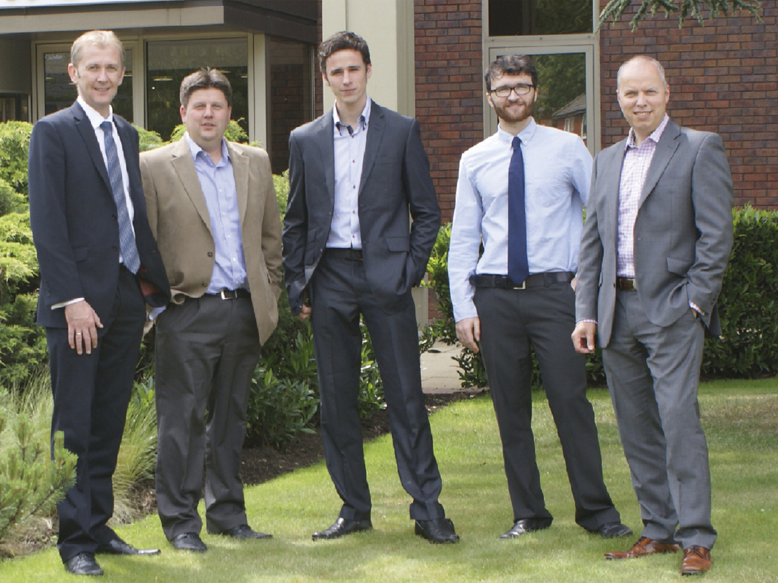
Area sales manager Andrew Norcliffe (left) leads the new team at B&R UK's Northern office. UK general manager Simon Goodwin (right) also attended the opening.

About B&R
B&R, a division of ABB Group, is a global leader in industrial automation headquartered in Austria. B&R combines state-of-the-art technology with advanced engineering to provide customers in virtually every industry with complete solutions for machine and factory automation, motion control, HMI and integrated safety technology. With Industrial IoT communication standards including OPC UA, POWERLINK and openSAFETY as well as its Automation Studio software, B&R is constantly redefining the future of automation engineering. The innovative spirit that keeps B&R at the forefront of industrial automation is driven by a commitment to simplifying processes and exceeding customer expectations.
For more information, visit www.br-automation.com.

