A revolution in automation software
B&R reduces development time by 67% with mapp technology
B&R will be presenting its revolutionary new mapp technology at this year's SPS IPC Drives trade show. These modular software blocks simplify the development of new programs and reduce the development time for new machines and systems by an average of 67%. At the same time, mapp solutions are much more convenient to service and maintain.
When it comes to engineering new machines and systems, software development is becoming an increasingly significant time and cost factor. Nevertheless, the lion's share of this work is spent on programming basic functions like loading recipe data.
Turbo boost for development using modular blocks
mapp eliminates these recurring programming tasks for developers by providing preconfigured blocks that are easy to use and already extensively tested. Programmers can then concentrate on their main task: implementing machine or system processes in the application software.
mapp blocks are seamlessly integrated into B&R's automation software landscape. This means that any developer who works with Automation Studio can implement mapp blocks to make their work easier and their application software clearer. The end results speak for themselves: increased machine availability, lower maintenance costs and much easier team collaboration.

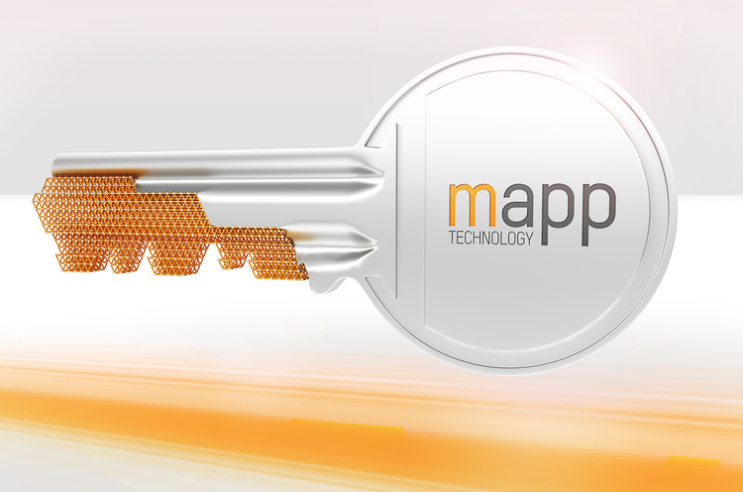
With mapp technology's modular software blocks B&R reduces the development time for new machines and systems by an average of 67%.

About B&R
B&R, a division of ABB Group, is a global leader in industrial automation headquartered in Austria. B&R combines state-of-the-art technology with advanced engineering to provide customers in virtually every industry with complete solutions for machine and factory automation, motion control, HMI and integrated safety technology. With Industrial IoT communication standards including OPC UA, POWERLINK and openSAFETY as well as its Automation Studio software, B&R is constantly redefining the future of automation engineering. The innovative spirit that keeps B&R at the forefront of industrial automation is driven by a commitment to simplifying processes and exceeding customer expectations.
For more information, visit www.br-automation.com.

