A revolution in automation software
B&R reduces development time by 67% with mapp technology
B&R will be presenting its revolutionary new mapp technology at this year's SPS IPC Drives trade show. These modular software blocks simplify the development of new programs and reduce the development time for new machines and systems by an average of 67%. At the same time, mapp solutions are much more convenient to service and maintain.
When it comes to engineering new machines and systems, software development is becoming an increasingly significant time and cost factor. Nevertheless, the lion's share of this work is spent on programming basic functions like loading recipe data.
Turbo boost for development using modular blocks
mapp eliminates these recurring programming tasks for developers by providing preconfigured blocks that are easy to use and already extensively tested. Programmers can then concentrate on their main task: implementing machine or system processes in the application software.
mapp blocks are seamlessly integrated into B&R's automation software landscape. This means that any developer who works with Automation Studio can implement mapp blocks to make their work easier and their application software clearer. The end results speak for themselves: increased machine availability, lower maintenance costs and much easier team collaboration.

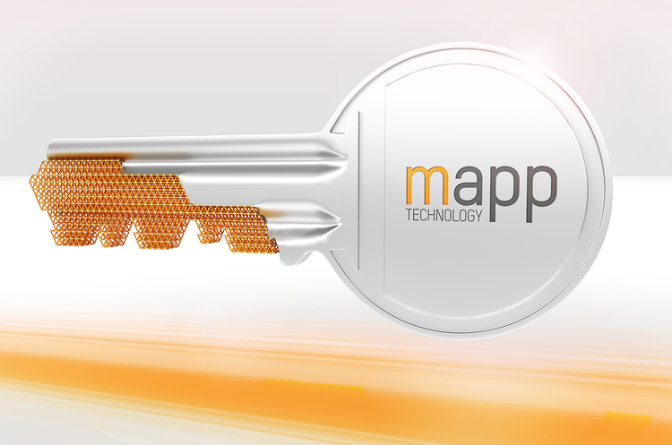
With mapp technology's modular software blocks B&R reduces the development time for new machines and systems by an average of 67%.

A proposito di B&R
B&R, una divisione del Gruppo ABB, è leader globale nell'automazione industriale con sede in Austria. B&R combina tecnologia all'avanguardia con ingegneria avanzata per fornire ai clienti, praticamente di ogni settore, soluzioni complete per l'automazione di macchine e fabbriche, controllo del movimento, HMI e tecnologia di sicurezza integrata. Con gli standard di comunicazione IoT industriale tra cui OPC UA, POWERLINK e openSAFETY, nonché il software Automation Studio, B&R ridefinisce costantemente il futuro dell'ingegneria dell'automazione. Lo spirito innovativo che mantiene B&R all'avanguardia nell'automazione industriale è guidato dall'impegno a semplificare i processi e a superare le aspettative dei clienti.
Per maggiori informazioni, visita www.br-automation.com

