High power packed in a compact housing
Automation PC 2100: Controller and PC in one
The new Automation PC 2100 from B&R unites the PC world with hard real-time applications. If needed, Automation Runtime and Windows can run at the same time thanks to powerful Intel Atom multi-core processing technology, allowing the Automation PC 2100 to be used simultaneously as a high-performance industrial controller as well as a PC for things like sophisticated HMI applications. And with such compact dimensions, it takes up hardly any space in the control cabinet at all.
Despite its ultracompact housing, the Automation PC 2100 is a full-fledged PC system that represents a milestone in the performance capabilities of embedded systems – with a price/performance ratio that can't be beat. Available with single-, dual- or quad-core processors, the computing power of the Automation PC 2100 is fully scalable. At the upper range of performance, it even exceeds the performance of many Core i-series processors.
Totally maintenance-free
Regardless of the variant, the absence of fans or other rotating components means that no maintenance whatsoever is required. Other standard features include two Gigabit Ethernet interfaces as well as one USB 2.0 and one USB 3.0 interface. Fieldbus connections such as POWERLINK or CAN can be individually configured, and compact MLC-based CFast cards with 60 GB or more are available to meet every memory need.
Maximum graphics performance
The graphics engine used by Intel Atom processors is derived from Core i technology and provides powerful processing all the way up to Full HD. This is also the first time that support for DirectX 11 is provided in this segment, opening up even more possibilities for enhanced graphic capabilities in SCADA and other HMI systems.

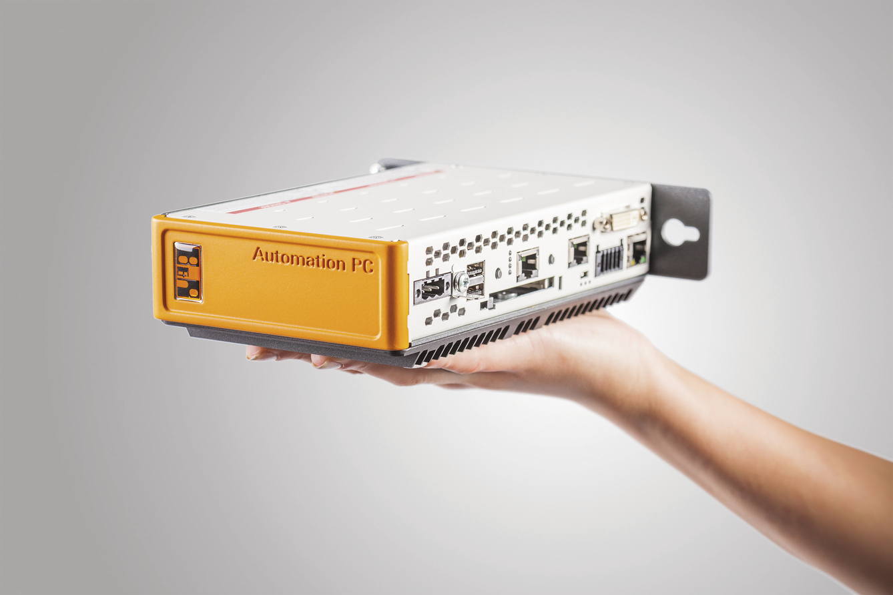
The Automation PC is barely larger than your hand yet still delivers maximum performance right where it's needed.

B&R Hakkında
ABB Grubunun bir bölümü olan B&R, merkezi Avusturya'da bulunan endüstriyel otomasyon alanında global bir liderdir. B&R, neredeyse her sektördeki müşterilere makine ve fabrika otomasyonu, hareket kontrolü, HMI ve entegre güvenlik teknolojisi için eksiksiz çözümler sunmak üzere en son teknolojiyi ileri mühendislikle birleştiriyor. OPC UA, POWERLINK ve openSAFETY gibi Endüstriyel IoT iletişim standartlarının yanı sıra Automation Studio yazılımıyla B&R, otomasyon mühendisliğinin geleceğini sürekli olarak yeniden tanımlıyor. B&R'ı endüstriyel otomasyonun ön saflarında tutan yenilikçi ruh, süreçleri basitleştirme ve müşteri beklentilerini aşma taahhüdünden kaynaklanmaktadır.
Daha fazla bilgi için www.br-automation.com adresini ziyaret edin.

