Strategic agreement between Datalogic and B&R
New UX vision processors relying on B&R's Automation PC 910
Datalogic Automation is gearing up to adopt low-consumption, high-performance B&R Automation PC 910 systems into its new UX series of vision processors. This is the result of the strategic agreement signed by both market leaders that will see the powerful B&R Automation PC 910 equipped as the new vision processor and providing support for Datalogic's industry-leading IMPACT machine vision software.
Up to 4 USB 3.0 cameras
Equipped with state-of-the-art technology like Intel's Core i-series processors and a wide range of standard video interfaces, the B&R Automation PC 910 is the ideal choice for demanding applications – including high-speed, high-resolution inspection and analysis. Combined with Datalogic's outstanding IMPACT software, the system can manage up to four USB 3.0 cameras to deliver unrivalled machine vision solutions.
UX vision processors support a wide portfolio of USB 3.0 vision cameras and can even handle different camera formats and resolutions with the same vision processor. With three configurations for high-powered image processing, they can be seamlessly integrated into standard factory networks as well as secondary software packages.

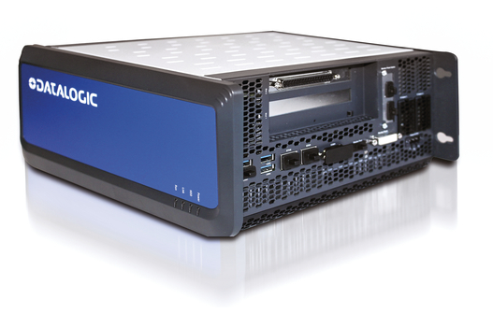
Datalogic's UX series vision system takes advantage of the high-performance B&R Automation PC 910.

About B&R
B&R, a division of ABB Group, is a global leader in industrial automation headquartered in Austria. B&R combines state-of-the-art technology with advanced engineering to provide customers in virtually every industry with complete solutions for machine and factory automation, motion control, HMI and integrated safety technology. With Industrial IoT communication standards including OPC UA, POWERLINK and openSAFETY as well as its Automation Studio software, B&R is constantly redefining the future of automation engineering. The innovative spirit that keeps B&R at the forefront of industrial automation is driven by a commitment to simplifying processes and exceeding customer expectations.
For more information, visit www.br-automation.com.

