High performance in a compact design
B&R presents the new ACOPOS P3 three-axis servo drive
B&R presented the new ACOPOS P3 at the 2015 SPS IPC Drives trade show. With a power density of 6 amps per liter of space, this innovative system is the most efficient servo drive with integrated safety functions available on the market. It also offers unrivaled dynamics and precision, with a sampling time of just 50 µs for the entire controller cascade.
Space required reduced by 69%
The ACOPOS P3 is offered as a 1-, 2- or 3-axis drive and covers a power spectrum ranging from 0.6 to 24 kW, or 1.2 to 48 amps. The housing of the three-axis drive is as small as a conventional one-axis drive, making it possible to reduce the amount of space required in the control cabinet by 69%.
A new dimension in virtual sensing
The short cycle time of 50 µs for current, speed and position control open up new possibilities for virtual sensor technology. Using a virtual motor position encoder eliminates the need for an encoder, encoder cable and evaluation unit in the servo drive and at the same time increases availability. Other special functions for more precise control and faster reactions – repetitive control, for example – can be implemented using virtual sensor technology.
Safety included
The ACOPOS P3 fits seamlessly into B&R's modular and fully scalable automation portfolio, allowing the creation and implementation of especially lean automation solutions. A Power Panel, any number of ACOPOS servo drives and X20 I/O modules are all that is needed to set up a complete and extremely powerful automation solution. Safety functions in accordance with SIL 3 / PL e can also be integrated upon request. Safely Limited Torque (SLT) and Remanent Safe Position (RSP) functions are new additions compared to previous ACOPOS models. And with a total of 14 safe motion functions based on openSAFETY, it is possible to satisfy all possible safety demands in an optimal way.
The ACOPOS P3 can be used anywhere in the world thanks to its support for the world's most common power mains configurations, such as TN, TT, IT and corner grounded TN-S systems. This also reduces the overall number of machine variants needed.

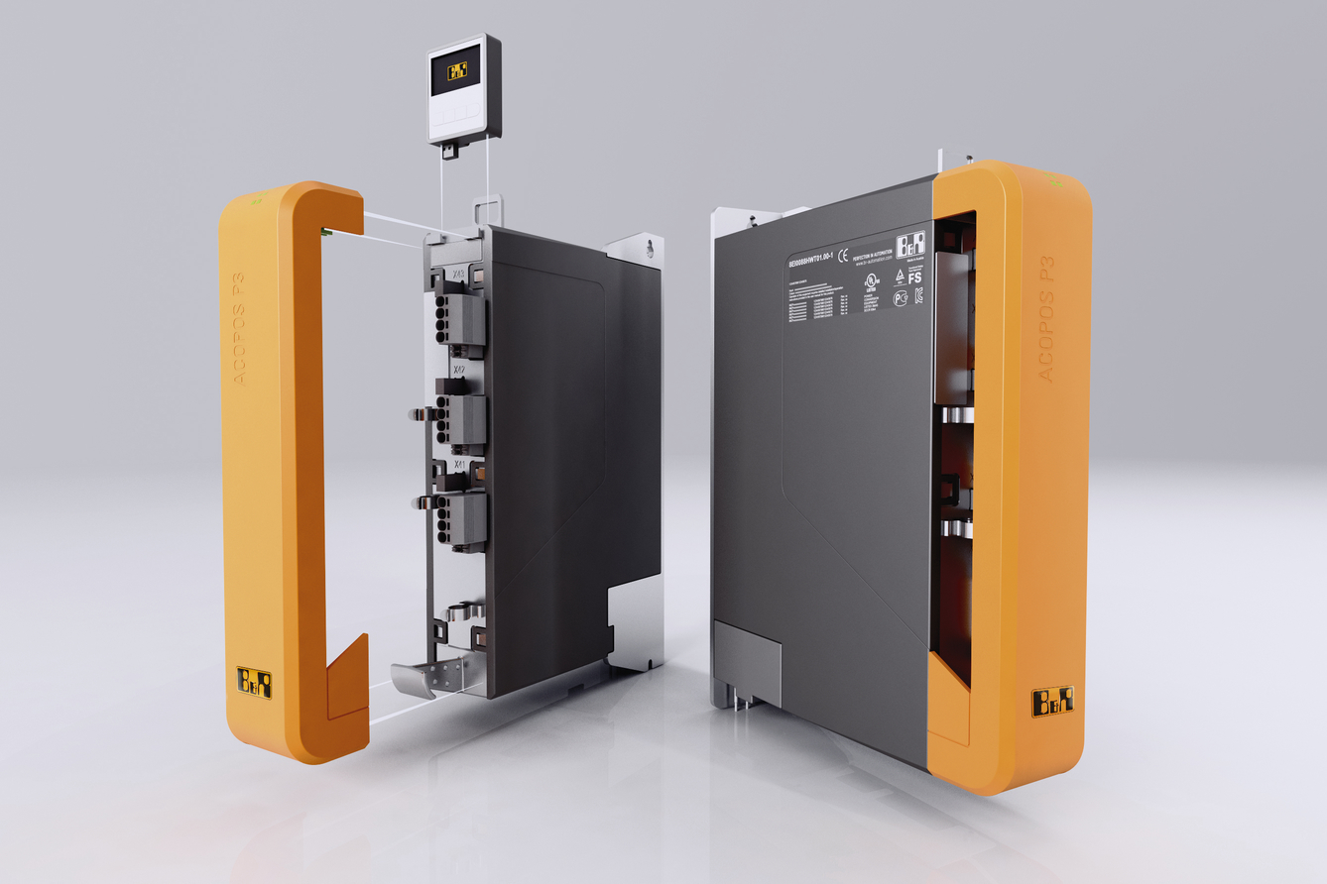
The ACOPOS P3 from B&R reduces the amount of space used in the control cabinet by up to 69%.

B&R Hakkında
ABB Grubunun bir bölümü olan B&R, merkezi Avusturya'da bulunan endüstriyel otomasyon alanında global bir liderdir. B&R, neredeyse her sektördeki müşterilere makine ve fabrika otomasyonu, hareket kontrolü, HMI ve entegre güvenlik teknolojisi için eksiksiz çözümler sunmak üzere en son teknolojiyi ileri mühendislikle birleştiriyor. OPC UA, POWERLINK ve openSAFETY gibi Endüstriyel IoT iletişim standartlarının yanı sıra Automation Studio yazılımıyla B&R, otomasyon mühendisliğinin geleceğini sürekli olarak yeniden tanımlıyor. B&R'ı endüstriyel otomasyonun ön saflarında tutan yenilikçi ruh, süreçleri basitleştirme ve müşteri beklentilerini aşma taahhüdünden kaynaklanmaktadır.
Daha fazla bilgi için www.br-automation.com adresini ziyaret edin.

