Service robot scales negative slopes
Unique stepping movements controlled by B&R technology
The Technical University of Liberec has introduced the second generation of its special service robot, the ROBOTUL® Vertical Climber 02, which uses a unique stepping movement to traverse both smooth and structured surfaces such as the glass walls of buildings. Its safe and highly precise operation is guaranteed by an advanced B&R control system with compact ACOPOSmicro servo drives.
The new approach taken by the Institute for Nanomaterials, Advanced Technologies and Innovation ensures linear movement, track stability and smooth rotation while enabling the robot to step over discontinuous surfaces and mounting holes. It can move with a high degree of safety on vertical – and even negatively sloped – walls. Based on feedback and experiences with its predecessor, this new generation is being developed in the context of the 3-year pre-seed project "New Technologies and Special Machine Components".
Wide range of applications
The Vertical Climber 02 is designed to clean walls and perform surface inspections such as checking mounting points on glass panels or checking the integrity of stainless steel pressure vessels. It can also be used as a mobile platform for other technology, including cleaning and dust-removal equipment. The robot has compact dimensions of 112x112x30 cm and weighs 48 kg. The maximum workload for the robot is 20 kg. Up to 80 sqm can be cleaned per hour, or up to 90 sqm inspected.
The body consists of a compact duralumin frame with a rotary servo drive connected to a rotary chassis. Its four moving legs are each driven by a separate rotary servo drive. The duralumin frame and the legs are equipped with articulated active suction caps combined with smart ejectors. Multiple smart sensors identify the position of the robot in space and with respect to the contact wall plane.
For more information on the project (in Czech), visit: Technical University of Liberic or preseed.cxi.tul.cz.

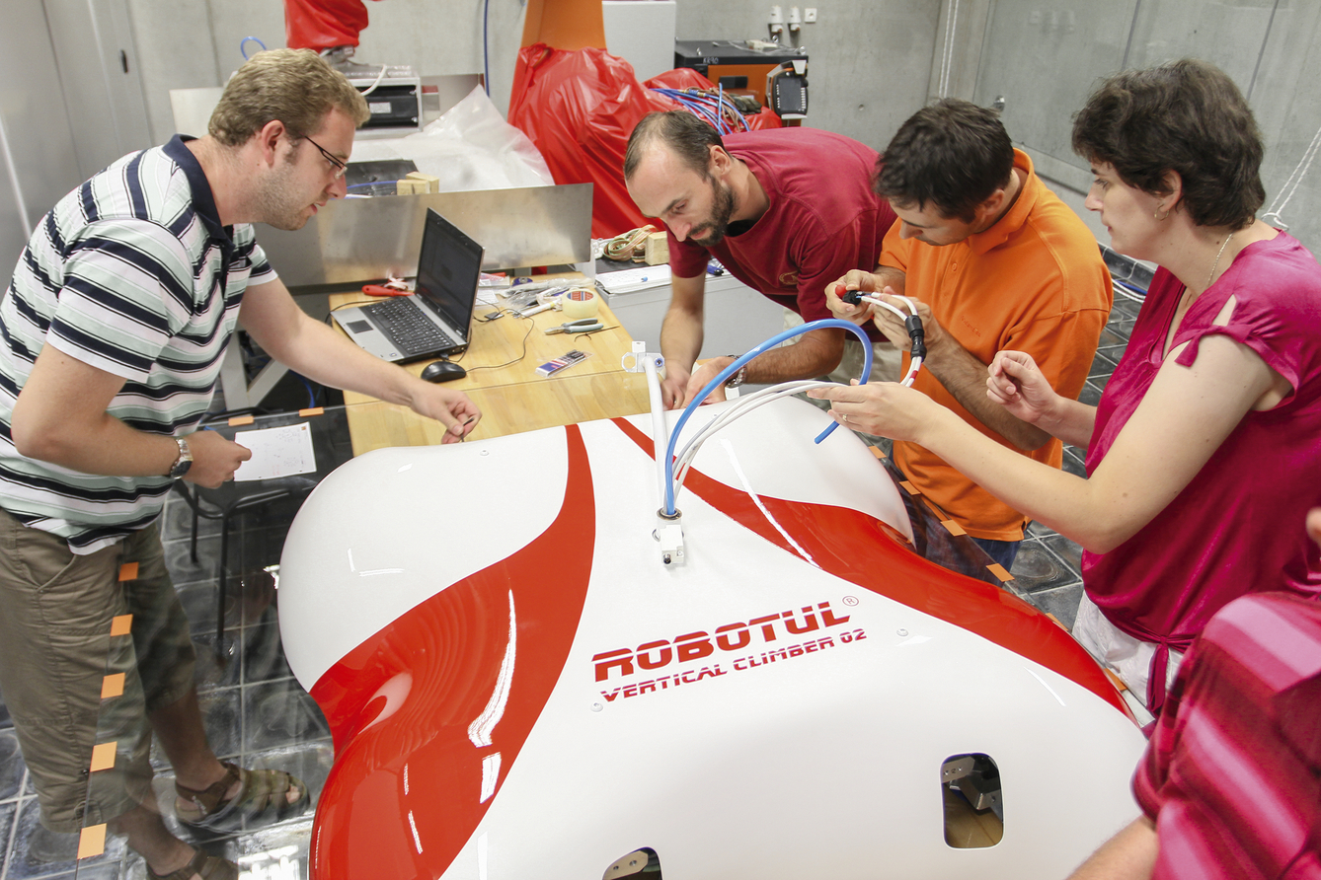
A team of the Technical University of Liberec prepares the ROBOTUL Vertical Climber.

About B&R
B&R, a division of ABB Group, is a global leader in industrial automation headquartered in Austria. B&R combines state-of-the-art technology with advanced engineering to provide customers in virtually every industry with complete solutions for machine and factory automation, motion control, HMI and integrated safety technology. With Industrial IoT communication standards including OPC UA, POWERLINK and openSAFETY as well as its Automation Studio software, B&R is constantly redefining the future of automation engineering. The innovative spirit that keeps B&R at the forefront of industrial automation is driven by a commitment to simplifying processes and exceeding customer expectations.
For more information, visit www.br-automation.com.

