B&R surpasses the half-billion mark
13% increase in sales: Automation specialist continues along the road to success
In the current year, B&R is expecting record sales revenue of €535 million, therefore surpassing the defined goal of a half-billion euros by a wide margin. This was announced by general manager Peter Gucher at B&R's annual press conference. With a 13% increase in sales, the company continues along the highly successful course laid out in previous years.
B&R increases market share
"We have considerably increased our market share," says Gucher. Whereas industrial production has only returned to pre-2008 levels in 2014, B&R sales have increased 75% during this time. B&R's core market is in Europe, where two-thirds of the company's sales are generated. The strongest increase in sales revenue was generated in Asia and North America.
Innovation fosters growth
In the past 12 months, machine and system manufacturers have automated 270,000 machines with B&R controllers. "The complete scalability of our entire product range gives us a clear competitive edge on the market," explains Gucher. "With Scalability+ solutions, we already offer the tools needed for flexible production as envisioned in the Industry 4.0 concept."
700 new engineers in 5 years
To ensure that its technologies remain on top in the automation industry, B&R invests nearly 15% of sales revenue back into research and development. "We can only continue along the road to success by developing new innovations," says Gucher. In the last five years alone, over 700 engineers have been hired. In addition, ten percent of all engineering hours is invested in training and continued education.
New subsidiary in Japan
B&R is represented by 24 subsidiaries and nearly 200 offices in 75 countries around the world. "Our decentralized structure is an essential part of B&R's business model," states Gucher. "We are in close proximity to our customers all around the world and always have sales and support engineers who speak the local language." Just in the last 12 months, B&R has opened many new offices, including the company's 24th subsidiary – this time in Japan. A complete team of support, application and sales engineers started work there in June.
Continued reliance on open standards
The real-time POWERLINK protocol – originally developed by B&R – has achieved the highest standardization level possible for a communication technology in China and is therefore considered a national standard. Its certification as a "Korean standard" is next in line. The open-source POWERLINK solution also cleared an impressive threshold this year, with over 1 million machines – or over 20 million nodes – now being used with POWERLINK in the field.
Innovations for Industry 4.0
Gucher also announced revolutionary innovations for developing application software that will be demonstrated at the 2014 SPS IPC Drives exhibition. "Machine and system manufacturers will be able to save a great deal of time and money in software engineering by using new mapp technology," he reported. With a new generation of highly versatile ACOPOS drive systems, B&R is also opening up new possibilities for increasing overall production flexibility. Another innovation, a business intelligence solution for the APROL process control system, makes it easy to intelligently organize and present big data in the areas of factory and process automation. "These new solutions not only align perfectly with current market trends, they will also ensure that B&R remains the yardstick by which new automation concepts are measured while allowing us to continue our role in shaping the future of industry," concluded Gucher.


B&R General Manager Peter Gucher: "Our innovations have helped us to considerably increase B&R's market share."
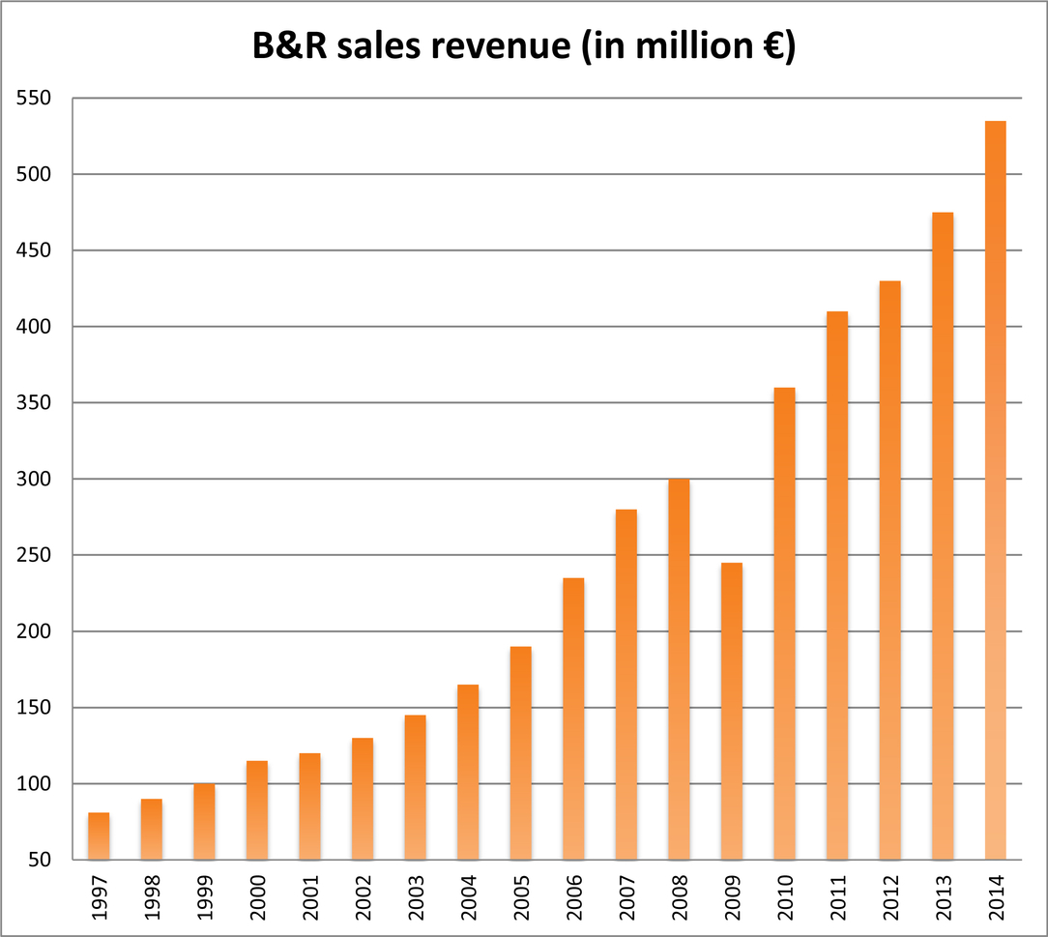
In 2014, B&R achieved sales revenue over €500 million for the first time.

B&R Hakkında
ABB Grubunun bir bölümü olan B&R, merkezi Avusturya'da bulunan endüstriyel otomasyon alanında global bir liderdir. B&R, neredeyse her sektördeki müşterilere makine ve fabrika otomasyonu, hareket kontrolü, HMI ve entegre güvenlik teknolojisi için eksiksiz çözümler sunmak üzere en son teknolojiyi ileri mühendislikle birleştiriyor. OPC UA, POWERLINK ve openSAFETY gibi Endüstriyel IoT iletişim standartlarının yanı sıra Automation Studio yazılımıyla B&R, otomasyon mühendisliğinin geleceğini sürekli olarak yeniden tanımlıyor. B&R'ı endüstriyel otomasyonun ön saflarında tutan yenilikçi ruh, süreçleri basitleştirme ve müşteri beklentilerini aşma taahhüdünden kaynaklanmaktadır.
Daha fazla bilgi için www.br-automation.com adresini ziyaret edin.

