Integrated safety technology awarded UL certification
B&R safety products comply with North American standards
B&R's extensive portfolio of integrated safety technology products has received yet another key certification. Following rigorous evaluation and testing, the experts at Underwriters Laboratories have confirmed that B&R products comply with IEC 61508, IEC 62061 and ISO 13849 – the recognized standards for safety technology. In particular, functional safety certification by UL verifies compliance with applicable North American standards such as ANSI/UL 1998.
Having successfully completed the certification process, B&R's portfolio of integrated safety technology is now UL-listed in the FSPC category (Energy and Industrial Systems Certified for Functional Safety), as well as the corresponding FSPC7 category for Canada.
Benefits for European machine manufacturers
The significance of this certification extends beyond B&R's customers in the North American market. For European manufacturers who supply machines to end customers in the USA and Canada, having B&R products listed under the FSPC/FSPC7 categories in the UL certification database makes it easier to obtain approval for machine installations in these markets.

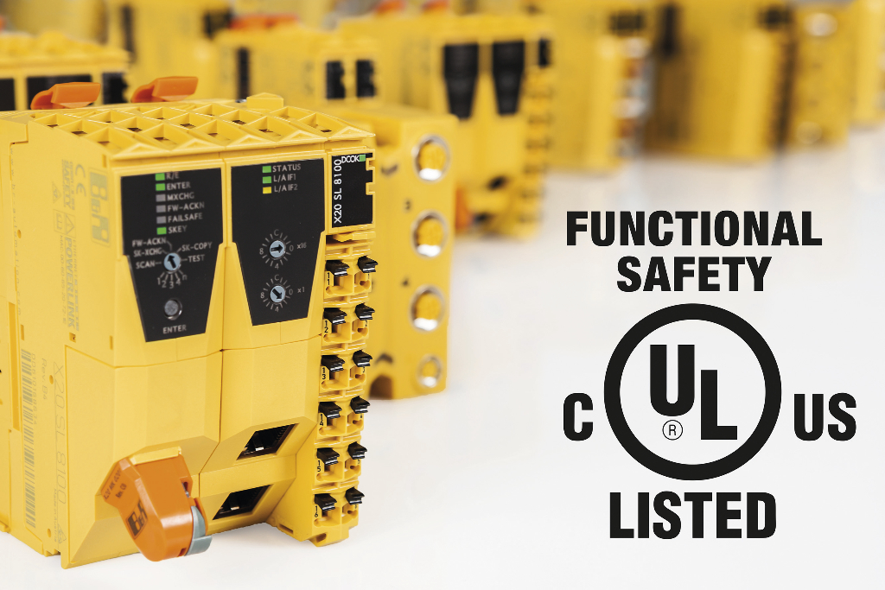
B&R's integrated safety technology has received UL functional safety certification.

About B&R
B&R, a division of ABB Group, is a global leader in industrial automation headquartered in Austria. B&R combines state-of-the-art technology with advanced engineering to provide customers in virtually every industry with complete solutions for machine and factory automation, motion control, HMI and integrated safety technology. With Industrial IoT communication standards including OPC UA, POWERLINK and openSAFETY as well as its Automation Studio software, B&R is constantly redefining the future of automation engineering. The innovative spirit that keeps B&R at the forefront of industrial automation is driven by a commitment to simplifying processes and exceeding customer expectations.
For more information, visit www.br-automation.com.

