B&R brings Industry 4.0 to China

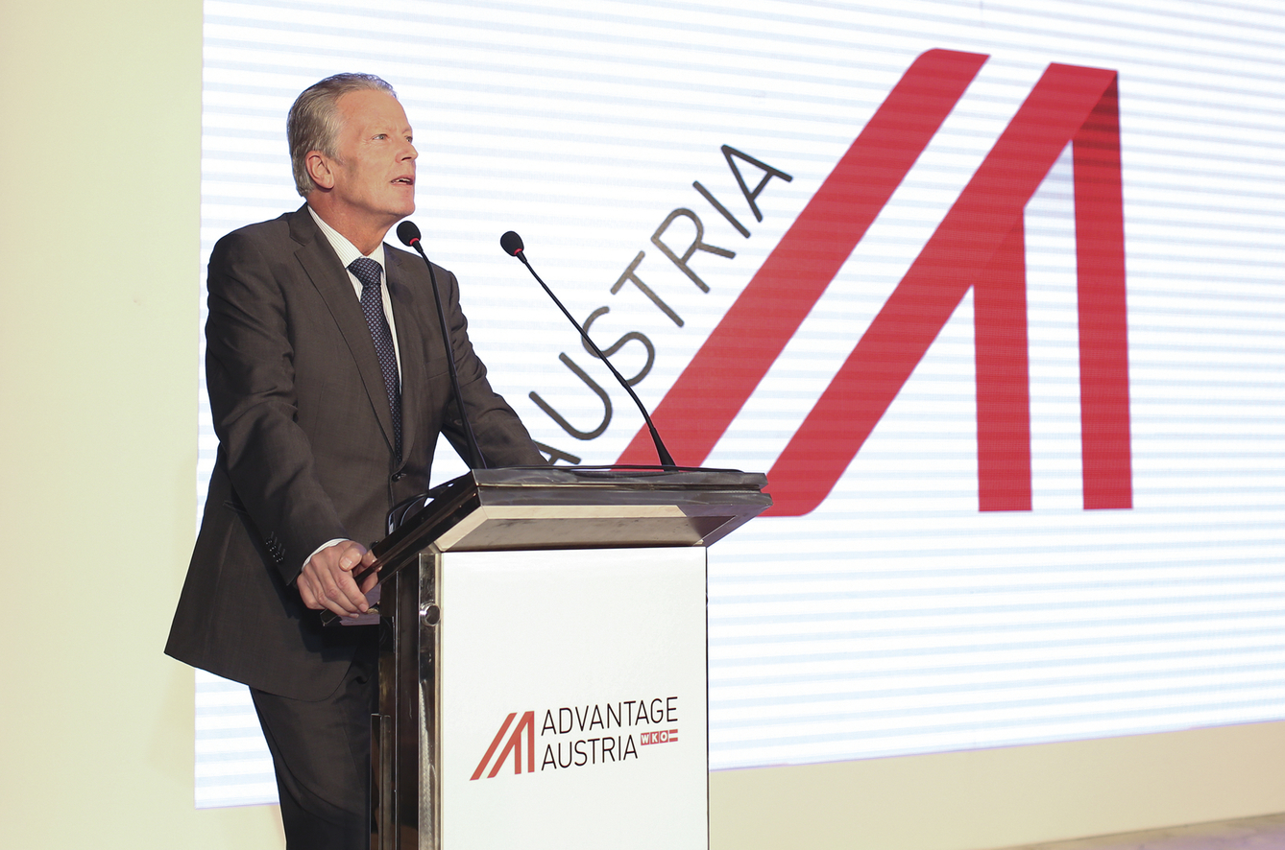
Austria's Federal Minister of Economy, Dr. Reinhold Mitterlehner, opens the Austria Connect Greater China conference in Shanghai. (Fotografía: AußenwirtschaftsCenter Shanghai))
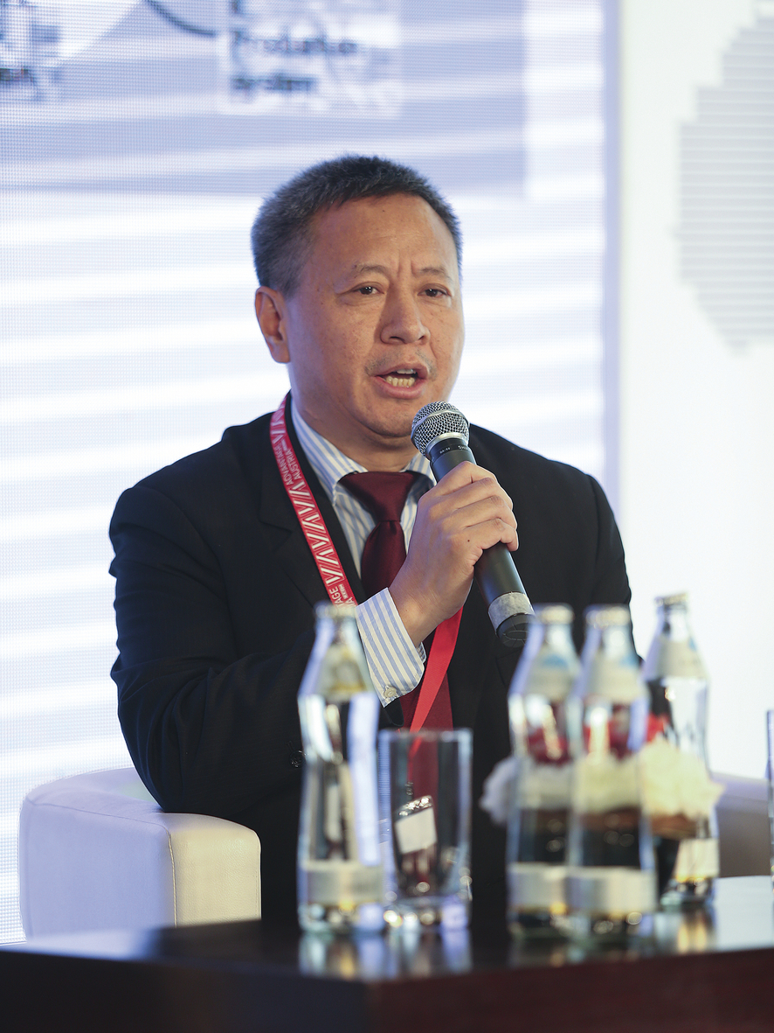
Dr. Xiao Weirong, Director General, B&R China: "B&R is a pioneer in the implementation of smart manufacturing technology." (Fotografía: AußenwirtschaftsCenter Shanghai))

Support for Austrian OEMs in Asia
For Austrian companies, China is gaining significance not only as a sales market, but also as a home for R&D and production. At the country's premier business event in Asia – Austria Connect Greater China – the president of the Austrian Federal Economic Chamber, Dr. Christoph Leitl, and Austria's Federal Minister of Economy, Dr. Reinhold Mitterlehner, observed how well cooperation between Austrian companies has been able to carry over into China.
Dr. Xiao Weirong, who heads B&R's subsidiary in China, highlighted the valuable support that B&R offers for Austrian OEMs along the road to Industry 4.0 – even when that road takes them far away from their familiar home territory. In a panel discussion on the future of production technology, Weirong described the immense pressure placed on manufacturers of machines and systems seeking to compete on a global scale. Only those who are able to react flexibly to changing consumer trends while maintaining cost-effective production can hope to establish a sustainable position on the market. OEMs hope to master these challenges by implementing the smart production methods of Industry 4.0.
On the road to the smart factory
B&R has many years of experience building solutions that merge mechatronic components with IT systems to form what are known as cyber-physical systems. "These are a key element of Industry 4.0, and they can be implemented today." Intelligent networks of mechatronic components in a smart factory also hold enormous potential for energy savings. "B&R is a pioneer in the implementation of smart manufacturing technology," says Weirong.
200 employees in China
B&R has had a wholly owned subsidiary in China since 1996. B&R China now boasts 200 employees in 10 locations, covering all of the nation's industrial centers that are home to European machine and systems manufacturers. "All of our Chinese employees speak English, and some of them German as well. This allows us to support our European customers quickly and efficiently," explains Werner Paulin, B&R's international sales manager responsible for the Greater China region.

