Solutions for smart factories
B&R User Meeting in Shanghai points the way into the future
In light of increasing pressure for end users and OEMs to implement "smart factory" solutions that merge automation and IT technology, B&R China's annual User Meeting addressed how companies can best meet the challenges of the future. With end users from a variety of industries making up 30% of the participants, the event itself illustrated the type of cooperation that Industry 4.0 calls for between automation suppliers, OEMs, end users and system integrators.
Sustainable solutions
Managing director of B&R China, Xiao Weirong, presented his vision of how industrial automation can respond to the challenges that lie ahead. "In order to remain competitive," he explained, "end users and OEMs need to create platforms for continuous innovation. Automation companies must provide them not simply with products, but with sustainable solutions that include training, support and operations management."
Equipped for the challenges to come
B&R presented the APROL process control system – and its turnkey solutions for energy monitoring, condition monitoring and process data acquisition – whose open architecture makes it easy to achieve the combination of automation and IT technology required by smart factories. Other B&R representatives introduced solutions for advanced maintenance technology, scalable and modular PC and panel systems and high-performance reACTION technology with 1 µs response times – all of which integrate tightly with applications of end-users and OEMs to solve problems today and long into the future.

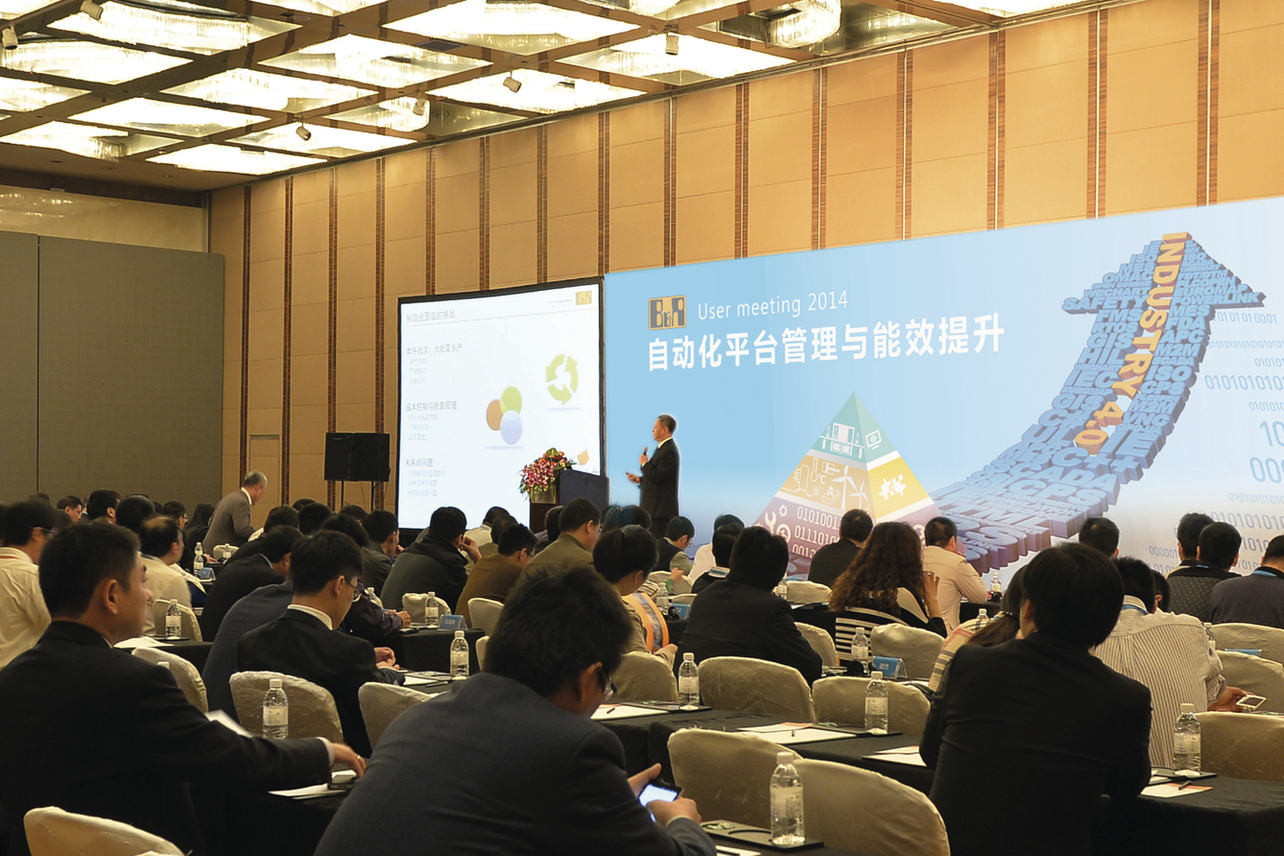
B&R's intelligent solutions will help its partners and customers strengthen their positions in the markets of tomorrow.

About B&R
B&R, a division of ABB Group, is a global leader in industrial automation headquartered in Austria. B&R combines state-of-the-art technology with advanced engineering to provide customers in virtually every industry with complete solutions for machine and factory automation, motion control, HMI and integrated safety technology. With Industrial IoT communication standards including OPC UA, POWERLINK and openSAFETY as well as its Automation Studio software, B&R is constantly redefining the future of automation engineering. The innovative spirit that keeps B&R at the forefront of industrial automation is driven by a commitment to simplifying processes and exceeding customer expectations.
For more information, visit www.br-automation.com.

