Standardization paves the way to the future
B&R software has now also received PLCopen certification for Coordinated Motion.
B&R's Automation Studio development platform now makes programming and configuring multi-axis systems easier than ever before. This is made possible with the addition of PLCopen-certified Coordinated Motion function blocks to the proven Generic Motion Control approach. B&R has constantly been adding to its portfolio of certified PLCopen blocks since 2004.
"Standardization paves the way to the future," stated Eelco van der Wal, managing director of the PLCopen Foundation, as he awarded the certificate of compliance at the SPS IPC Drives trade fair in Nuremberg, Germany. "Modular and individual machine concepts can only become reality when it is possible to swap out components from different manufacturers."
Vendor-independent
PLCopen Motion Control Part 4 – Coordinated Motion specifications encompass predefined function blocks and machine state descriptions that make it possible to control any multi-axis system with a standardized interface. "What these PLCopen blocks have done is made it just as easy to configure any type of robot – regardless of its kinematic structure – as it is to set up single axes," explains Gernot Bachler, technical manager of Motion at B&R. Identical command execution is guaranteed by the use of standardized interfaces. "Not a single line of code needs to be changed."

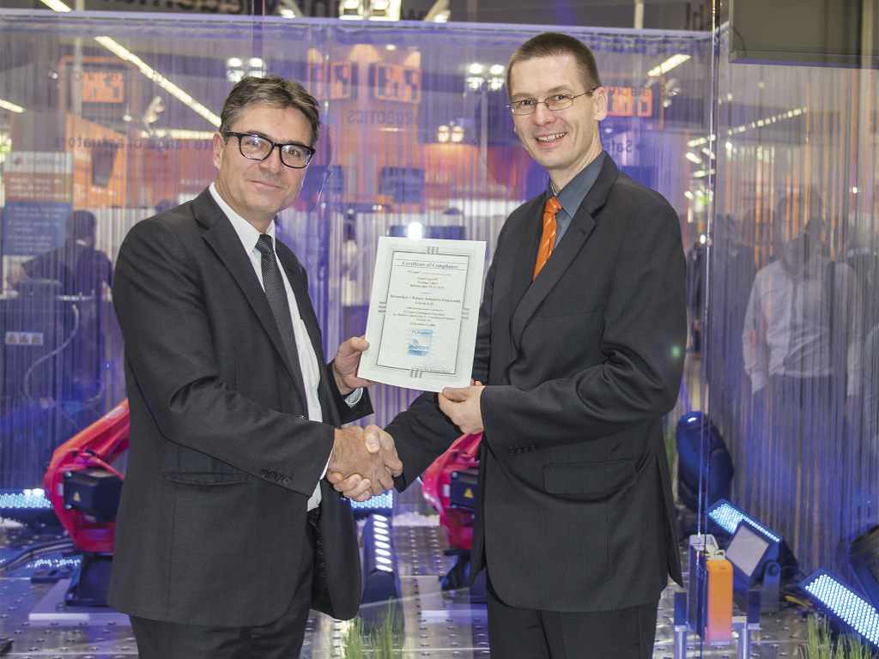
Gernot Bachler (technical manager of Motion at B&R) receives the certificate of compliance from Eelco van der Wal (managing director of the PLCopen Foundation) at the SPS IPC Drives trade fair.

About B&R
B&R, a division of ABB Group, is a global leader in industrial automation headquartered in Austria. B&R combines state-of-the-art technology with advanced engineering to provide customers in virtually every industry with complete solutions for machine and factory automation, motion control, HMI and integrated safety technology. With Industrial IoT communication standards including OPC UA, POWERLINK and openSAFETY as well as its Automation Studio software, B&R is constantly redefining the future of automation engineering. The innovative spirit that keeps B&R at the forefront of industrial automation is driven by a commitment to simplifying processes and exceeding customer expectations.
For more information, visit www.br-automation.com.

