Safe pressing made easy
B&R implements library of PLCopen function blocks
With the SafeDESIGNER library for press applications, B&R is one of the first manufacturers to offer a complete set of the function blocks specified in PLCopen part 4. As a result, users working with safety-critical press applications will have a much easier time setting up the necessary safety functions.
Vendor-independent specifications
Over the past several years, PLCopen has worked intensively on a specification for function blocks in press applications, with B&R playing an instrumental role in this development. The result is part 4 of the PLCopen safety specification, which defines safety aspects of mechanical, electrical and hydraulic presses. Also defined in this specification were the corresponding vendor-independent function blocks for the safety application.
PLCopen specifications provide solutions for machine manufacturers that are open to all, not just a few manufacturers. The PLCopen Safety working group brings together engineers from leading industrial automation companies as well as experts from certifying institutions who work closely with safety-related technology. For many years now, B&R has been involved in this consortium.

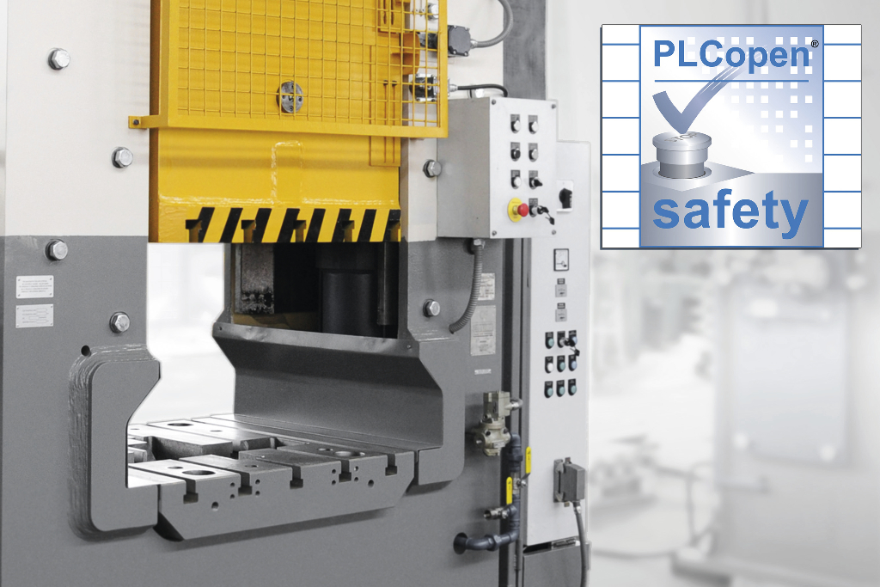
B&R is one of the first manufacturers to offer a set of the function blocks specified in PLCopen part 4 for press applications.

About B&R
B&R, a division of ABB Group, is a global leader in industrial automation headquartered in Austria. B&R combines state-of-the-art technology with advanced engineering to provide customers in virtually every industry with complete solutions for machine and factory automation, motion control, HMI and integrated safety technology. With Industrial IoT communication standards including OPC UA, POWERLINK and openSAFETY as well as its Automation Studio software, B&R is constantly redefining the future of automation engineering. The innovative spirit that keeps B&R at the forefront of industrial automation is driven by a commitment to simplifying processes and exceeding customer expectations.
For more information, visit www.br-automation.com.

