Safe pressing made easy
B&R implements library of PLCopen function blocks
With the SafeDESIGNER library for press applications, B&R is one of the first manufacturers to offer a complete set of the function blocks specified in PLCopen part 4. As a result, users working with safety-critical press applications will have a much easier time setting up the necessary safety functions.
Vendor-independent specifications
Over the past several years, PLCopen has worked intensively on a specification for function blocks in press applications, with B&R playing an instrumental role in this development. The result is part 4 of the PLCopen safety specification, which defines safety aspects of mechanical, electrical and hydraulic presses. Also defined in this specification were the corresponding vendor-independent function blocks for the safety application.
PLCopen specifications provide solutions for machine manufacturers that are open to all, not just a few manufacturers. The PLCopen Safety working group brings together engineers from leading industrial automation companies as well as experts from certifying institutions who work closely with safety-related technology. For many years now, B&R has been involved in this consortium.

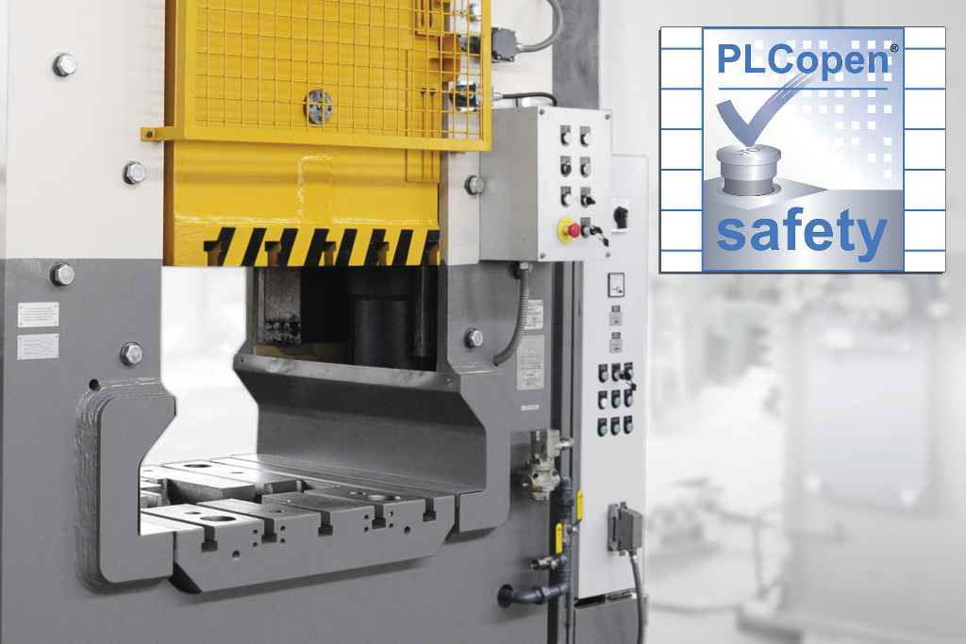
B&R is one of the first manufacturers to offer a set of the function blocks specified in PLCopen part 4 for press applications.

A proposito di B&R
B&R, una divisione del Gruppo ABB, è leader globale nell'automazione industriale con sede in Austria. B&R combina tecnologia all'avanguardia con ingegneria avanzata per fornire ai clienti, praticamente di ogni settore, soluzioni complete per l'automazione di macchine e fabbriche, controllo del movimento, HMI e tecnologia di sicurezza integrata. Con gli standard di comunicazione IoT industriale tra cui OPC UA, POWERLINK e openSAFETY, nonché il software Automation Studio, B&R ridefinisce costantemente il futuro dell'ingegneria dell'automazione. Lo spirito innovativo che mantiene B&R all'avanguardia nell'automazione industriale è guidato dall'impegno a semplificare i processi e a superare le aspettative dei clienti.
Per maggiori informazioni, visita www.br-automation.com

