Compact and dynamic
8LS motor series from B&R now even more powerful
Motors from B&R's 8LS series have been completely revamped and are now more powerful than ever. A more compact housing, optimized design and additional sizes are only some of the features that make these motors even more attractive and universal.
B&R has improved the already very powerful and dynamic servo motors from the 8LS series in many details. For example, size 2 and 3 motors with the same technical data are now much more compact, guaranteeing maximum compatibility with a higher power density. Size 5 and 7 motors are available in additional lengths, thereby offering more flexibility in terms of dynamics and torque.
Safety included
8LS motors use new inductive encoders that deliver extremely precise data compared to previous encoders. In combination with the digital EnDat 2.2 interface, the most common safety functions can also be used with hybrid motor cables where the encoder and motor cables are grouped together, reducing wiring effort and costs.
The most commonly used 8LS series motors are also available as preferred motors. For our customers, this means an unbeatable price/performance ratio and reduced delivery times. If necessary, these motors can be ready on short notice and dispatched using express delivery.

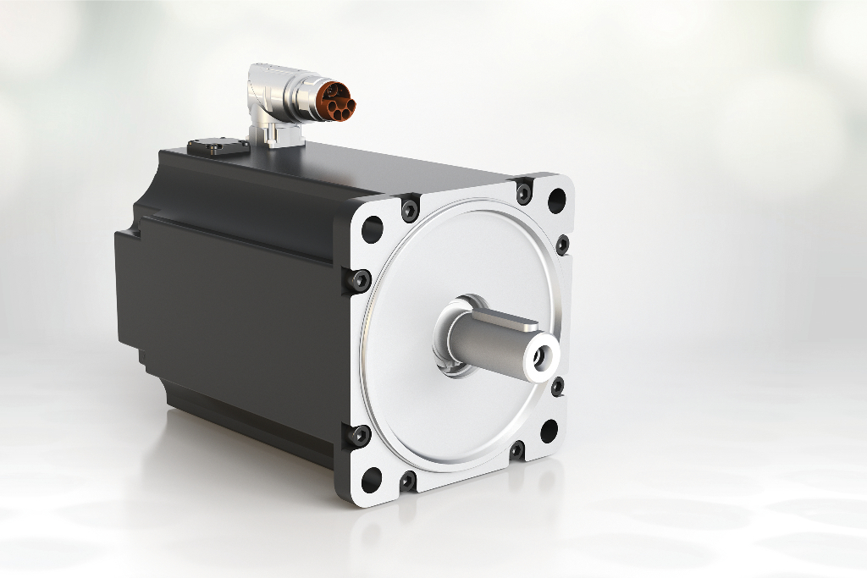
B&R has completely revamped the 8LS series of motors and implemented numerous improvements in the process.

A proposito di B&R
B&R, una divisione del Gruppo ABB, è leader globale nell'automazione industriale con sede in Austria. B&R combina tecnologia all'avanguardia con ingegneria avanzata per fornire ai clienti, praticamente di ogni settore, soluzioni complete per l'automazione di macchine e fabbriche, controllo del movimento, HMI e tecnologia di sicurezza integrata. Con gli standard di comunicazione IoT industriale tra cui OPC UA, POWERLINK e openSAFETY, nonché il software Automation Studio, B&R ridefinisce costantemente il futuro dell'ingegneria dell'automazione. Lo spirito innovativo che mantiene B&R all'avanguardia nell'automazione industriale è guidato dall'impegno a semplificare i processi e a superare le aspettative dei clienti.
Per maggiori informazioni, visita www.br-automation.com

