Humans and robots, hand in hand
B&R presents new solutions at Anuga FoodTec
New solutions for cooperation between humans and robots in the food and beverage industry will be the focal point of B&R's exhibit in Hall 7 / Booth 39 at the Anuga FoodTec trade fair being held March 24-27 in Cologne, Germany.
"Our SafeROBOTICS functions eliminate the need for a safety cage and allow robots and human operators to work hand in hand," explains Enrico Paolucci, B&R's global account manager for the food and beverage industry. In addition to the already well-established functions for monitoring the speed of a robot's joints and tool center point (TCP), B&R's range of SafeROBOTICS functions has been expanded to include monitoring of workspace boundaries and the orientation of the tool mounting flange. "This makes it even easier to achieve the higher levels of flexibility and tighter integration of robotics and automation demanded by Industry 4.0."
"With the fourth industrial revolution, the complexity of production processes is growing rapidly," says Paolucci. In an effort to adapt to these new challenges, food and beverage companies are increasingly turning to automation technology. "That's why we're making our first appearance at Anuga FoodTec this year." B&R offers food and beverage producers integrated automation solutions that can increase their competitive edge as they transition to Industry 4.0.

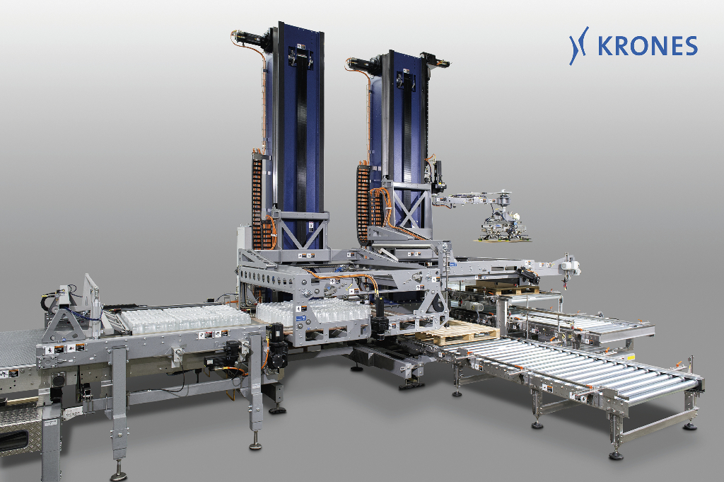
B&R technology provides the high degree of production flexibility essential for companies in the food and beverage industry to meet the challenges of the future. A control and drive system from B&R allows this palletizer to react to changes in the production process – flexibly and fully automatically. Photo: KRONES AG

A proposito di B&R
B&R, una divisione del Gruppo ABB, è leader globale nell'automazione industriale con sede in Austria. B&R combina tecnologia all'avanguardia con ingegneria avanzata per fornire ai clienti, praticamente di ogni settore, soluzioni complete per l'automazione di macchine e fabbriche, controllo del movimento, HMI e tecnologia di sicurezza integrata. Con gli standard di comunicazione IoT industriale tra cui OPC UA, POWERLINK e openSAFETY, nonché il software Automation Studio, B&R ridefinisce costantemente il futuro dell'ingegneria dell'automazione. Lo spirito innovativo che mantiene B&R all'avanguardia nell'automazione industriale è guidato dall'impegno a semplificare i processi e a superare le aspettative dei clienti.
Per maggiori informazioni, visita www.br-automation.com

