Reliable verification of quality
APROL PDA for easy-to-use, centralized process data acquisition
Centralized acquisition of operating and process data from machines and equipment using B&R's APROL process control system is now much easier. The new APROL PDA solution has a PDA browser, PDA function blocks and a PDA visualization element. APROL PDA can be used alone as an off-the-shelf solution or integrated into an existing APROL system.
Centralized data acquisition allows for comprehensive online performance monitoring and clear visual overviews. Powerful and extremely reliable long-term archiving makes it possible to track quality for the entire manufacturing process. Highly flexible reports with integrated analysis functions facilitate efforts to optimize production. The combined display of continuous data, alarms and events in the TrendViewer make it easy to trace cause and effect.
One view, multiple HMI applications
The new APROL VNC Viewer and VNC Viewer visualization elements are now available for embedding multiple HMI applications in a single process graphic. The VNC Viewer allows multiple HMI applications – regardless of their respective platforms – to be scaled as needed and displayed in a single process graphic. A web widget is also available for embedding web pages. This can be used to view HMI applications based on HTML 5, content from IP cameras or business intelligence reports.

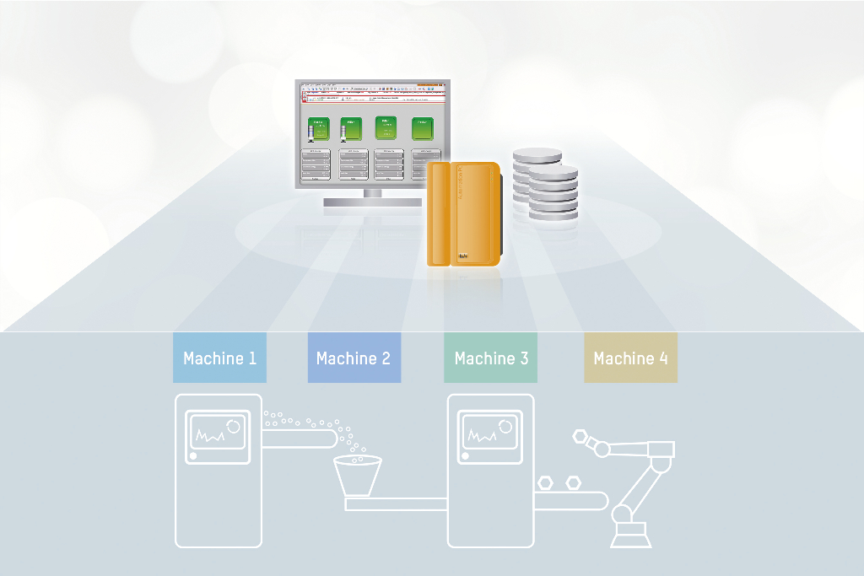
Centralized acquisition of operating and process data is much easier with APROL PDA.

About B&R
B&R, a division of ABB Group, is a global leader in industrial automation headquartered in Austria. B&R combines state-of-the-art technology with advanced engineering to provide customers in virtually every industry with complete solutions for machine and factory automation, motion control, HMI and integrated safety technology. With Industrial IoT communication standards including OPC UA, POWERLINK and openSAFETY as well as its Automation Studio software, B&R is constantly redefining the future of automation engineering. The innovative spirit that keeps B&R at the forefront of industrial automation is driven by a commitment to simplifying processes and exceeding customer expectations.
For more information, visit www.br-automation.com.

