Commission robots quickly and easily
B&R expands mapp technology portfolio to include blocks for robot kinematics.
B&R is expanding its already extensive mapp technology portfolio to include function blocks for all the most commonly used robot kinematic systems. Not only does this allow users to commission robots much more quickly, it also makes maintenance and diagnostics substantially easier.
The new robotic functions in mapp include both serial and parallel robot kinematics, such as SCARA and delta robots. The user interface is based on familiar IEC 61131 programming methods. The robotic functions integrate seamlessly into the overall system, so there is no need for a dedicated robotics controller.
Configuring, not programming
The robot kinematics themselves are configured graphically in a convenient web interface. Programming in the conventional sense is not necessary. The mapp blocks can even handle manual operations such as jogging and point-to-point movement of the tool center point. Technicians can run diagnostics on the robot via the easy-to-use web interface.
mapp technology consists of individually encapsulated blocks that streamline development of new software. The components provide basic functionality and are configured graphically. Each mapp component retrieves the data it needs from other components using a client-server model. With mapp technology, development of application software is accelerated by an average of 67%.

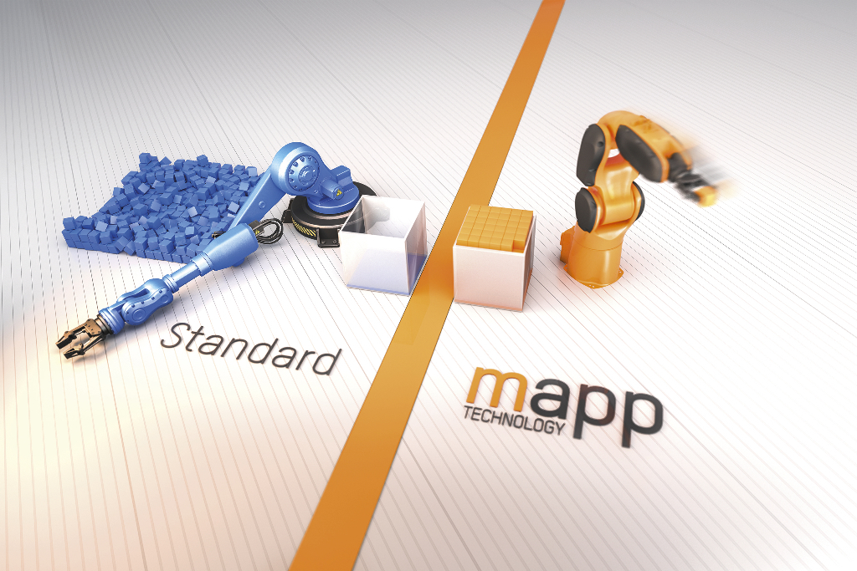
Robots can be commissioned much more quickly and easily with mapp technology.

About B&R
B&R, a division of ABB Group, is a global leader in industrial automation headquartered in Austria. B&R combines state-of-the-art technology with advanced engineering to provide customers in virtually every industry with complete solutions for machine and factory automation, motion control, HMI and integrated safety technology. With Industrial IoT communication standards including OPC UA, POWERLINK and openSAFETY as well as its Automation Studio software, B&R is constantly redefining the future of automation engineering. The innovative spirit that keeps B&R at the forefront of industrial automation is driven by a commitment to simplifying processes and exceeding customer expectations.
For more information, visit www.br-automation.com.

