Powerful computing for bridges and offshore systems
Industrial PC from B&R awarded DNV GL certification
B&R's Automation PC 910 has been awarded DNV GL certification for maritime applications. The industrial PC has been certified in accordance with GL 2010, IACS UR E10. Additionally, DNV GL confirms its compliance with IEC 60945, including the specified Compass Safe Distance. The Automation PC 910 is now available for use in many maritime and offshore applications.
The rugged construction of B&R's industrial PCs has clear advantages when installed on vessels and in harsh maritime environments. The Automation PC has no internal cable connections and does not require shock absorbers or any other auxiliary installation equipment.
Countless potential applications
Typical applications for the Automation PC 910 include highly integrated bridge systems, electronic chart display and information systems, vessel information systems and voyage data recorders. It is also used in distributed vessel control systems, offshore monitoring and control applications and dynamic positioning systems, as well as to provide condition monitoring for power transmission and power distribution systems or serve as the master or SCADA station in integrated automation systems.
The Automation PC 910 guarantees exceptional long-term availability. With a selection of processors ranging from Celeron to Core i7, the performance can be scaled to any application. The flexible interface options range from Gigabit Ethernet to USB 3.0, as well as POWERLINK, CAN and RS232/422/485 for use with real-time operating systems.

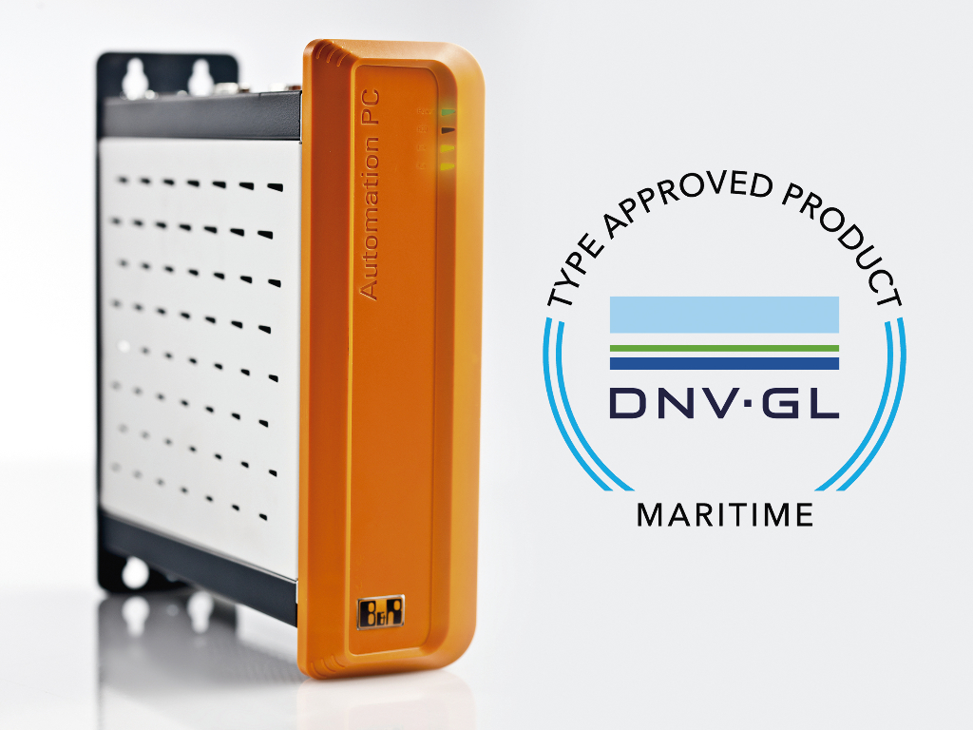
The Automation PC 910 has been certified for maritime applications by the DNV GL organization.

About B&R
B&R, a division of ABB Group, is a global leader in industrial automation headquartered in Austria. B&R combines state-of-the-art technology with advanced engineering to provide customers in virtually every industry with complete solutions for machine and factory automation, motion control, HMI and integrated safety technology. With Industrial IoT communication standards including OPC UA, POWERLINK and openSAFETY as well as its Automation Studio software, B&R is constantly redefining the future of automation engineering. The innovative spirit that keeps B&R at the forefront of industrial automation is driven by a commitment to simplifying processes and exceeding customer expectations.
For more information, visit www.br-automation.com.

