Powerful computing for bridges and offshore systems
Industrial PC from B&R awarded DNV GL certification
B&R's Automation PC 910 has been awarded DNV GL certification for maritime applications. The industrial PC has been certified in accordance with GL 2010, IACS UR E10. Additionally, DNV GL confirms its compliance with IEC 60945, including the specified Compass Safe Distance. The Automation PC 910 is now available for use in many maritime and offshore applications.
The rugged construction of B&R's industrial PCs has clear advantages when installed on vessels and in harsh maritime environments. The Automation PC has no internal cable connections and does not require shock absorbers or any other auxiliary installation equipment.
Countless potential applications
Typical applications for the Automation PC 910 include highly integrated bridge systems, electronic chart display and information systems, vessel information systems and voyage data recorders. It is also used in distributed vessel control systems, offshore monitoring and control applications and dynamic positioning systems, as well as to provide condition monitoring for power transmission and power distribution systems or serve as the master or SCADA station in integrated automation systems.
The Automation PC 910 guarantees exceptional long-term availability. With a selection of processors ranging from Celeron to Core i7, the performance can be scaled to any application. The flexible interface options range from Gigabit Ethernet to USB 3.0, as well as POWERLINK, CAN and RS232/422/485 for use with real-time operating systems.

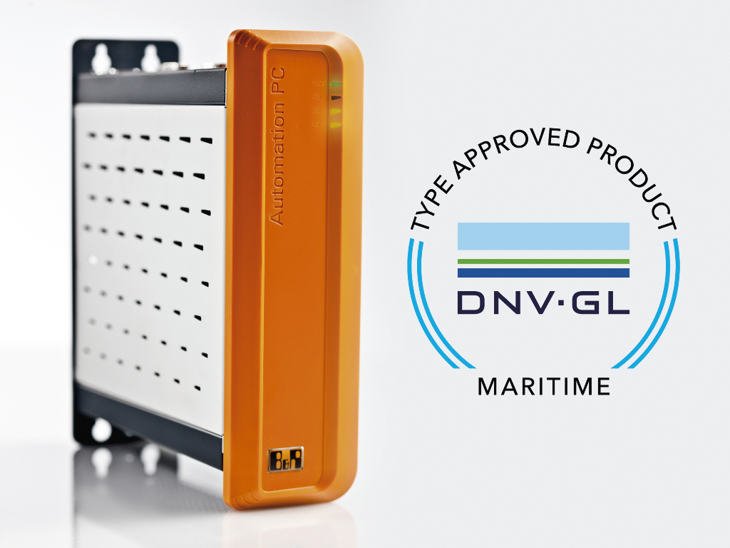
The Automation PC 910 has been certified for maritime applications by the DNV GL organization.

A proposito di B&R
B&R, una divisione del Gruppo ABB, è leader globale nell'automazione industriale con sede in Austria. B&R combina tecnologia all'avanguardia con ingegneria avanzata per fornire ai clienti, praticamente di ogni settore, soluzioni complete per l'automazione di macchine e fabbriche, controllo del movimento, HMI e tecnologia di sicurezza integrata. Con gli standard di comunicazione IoT industriale tra cui OPC UA, POWERLINK e openSAFETY, nonché il software Automation Studio, B&R ridefinisce costantemente il futuro dell'ingegneria dell'automazione. Lo spirito innovativo che mantiene B&R all'avanguardia nell'automazione industriale è guidato dall'impegno a semplificare i processi e a superare le aspettative dei clienti.
Per maggiori informazioni, visita www.br-automation.com

