Safety for the wood industry
B&R presents low-cost safety solutions at Ligna
Programmable safety technology is no longer more expensive than a conventional safety relay. B&R's new safe I/O modules make programmable safety technology an economical solution even for woodworking applications on the smallest scale. These and other innovations will be on display in Hall 17 / Booth G20 at the Ligna trade fair from May 11-15 in Hanover.
Another way B&R can help its customers deal with cost pressure in the wood industry is with its compact controllers, which are designed to save space and optimize costs. B&R's web terminals (Power Panel T-Series) and terminals featuring an integrated controller (Power Panel C-Series) are also perfect for the wood industry. The harsh production environments are no problem thanks to their IP65 protection.
Plastics expertise for WPC
Wood-plastic composites (WPCs) represent a promising market for the wood industry. The production of WPCs involves techniques such as extrusion and injection molding that are unconventional for wood processors. This is where B&R's customers in the wood industry stand to profit from B&R's many years of in-depth experience in plastics processing.

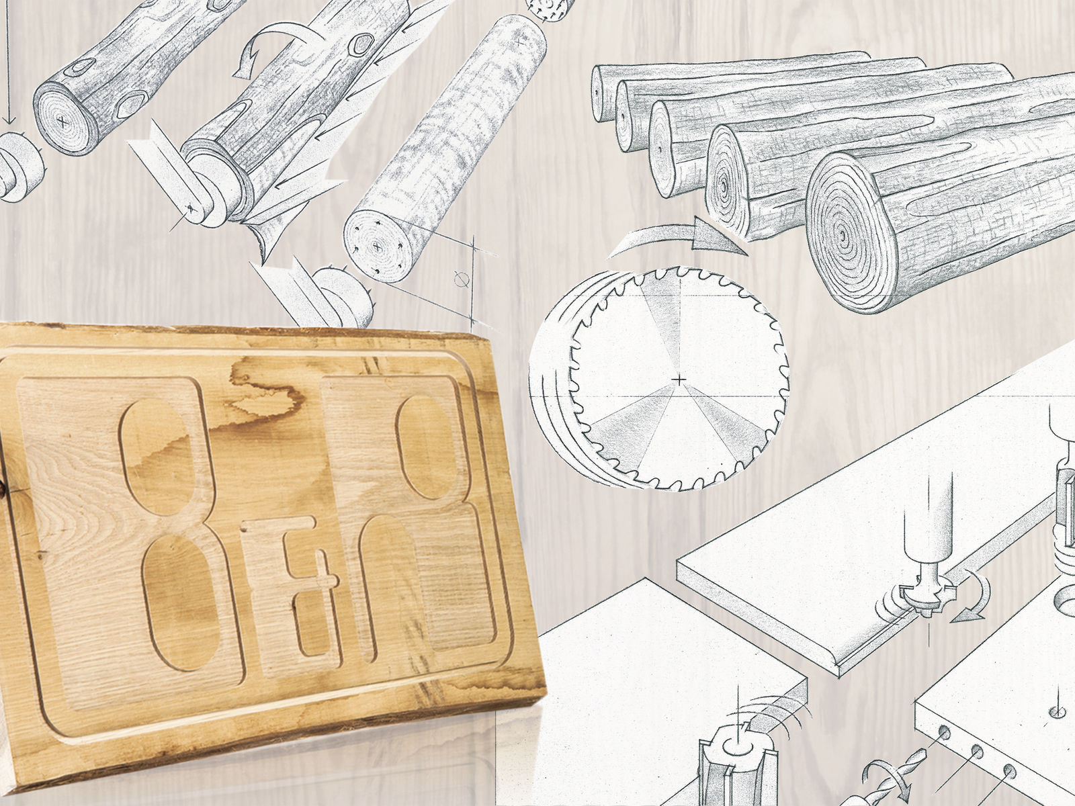
B&R will be showcasing its latest innovations for the wood industry at Ligna.

About B&R
B&R, a division of ABB Group, is a global leader in industrial automation headquartered in Austria. B&R combines state-of-the-art technology with advanced engineering to provide customers in virtually every industry with complete solutions for machine and factory automation, motion control, HMI and integrated safety technology. With Industrial IoT communication standards including OPC UA, POWERLINK and openSAFETY as well as its Automation Studio software, B&R is constantly redefining the future of automation engineering. The innovative spirit that keeps B&R at the forefront of industrial automation is driven by a commitment to simplifying processes and exceeding customer expectations.
For more information, visit www.br-automation.com.

