Safety for the wood industry
B&R presents low-cost safety solutions at Ligna
可编程安全技术将不再比传统安全继电器更昂贵。贝加莱新型安全I/O模块使得可编程安全技术成为经济型解决方案，即使面对小规模木工应用。这些及其它创新将在5月11至15日于汉诺威举办的Ligna展会上展示，展台号：Hall 17 / Booth G20。
Another way B&R can help its customers deal with cost pressure in the wood industry is with its compact controllers, which are designed to save space and optimize costs. B&R's web terminals (Power Panel T-Series) and terminals featuring an integrated controller (Power Panel C-Series) are also perfect for the wood industry. The harsh production environments are no problem thanks to their IP65 protection.
Plastics expertise for WPC
Wood-plastic composites (WPCs) represent a promising market for the wood industry. The production of WPCs involves techniques such as extrusion and injection molding that are unconventional for wood processors. This is where B&R's customers in the wood industry stand to profit from B&R's many years of in-depth experience in plastics processing.

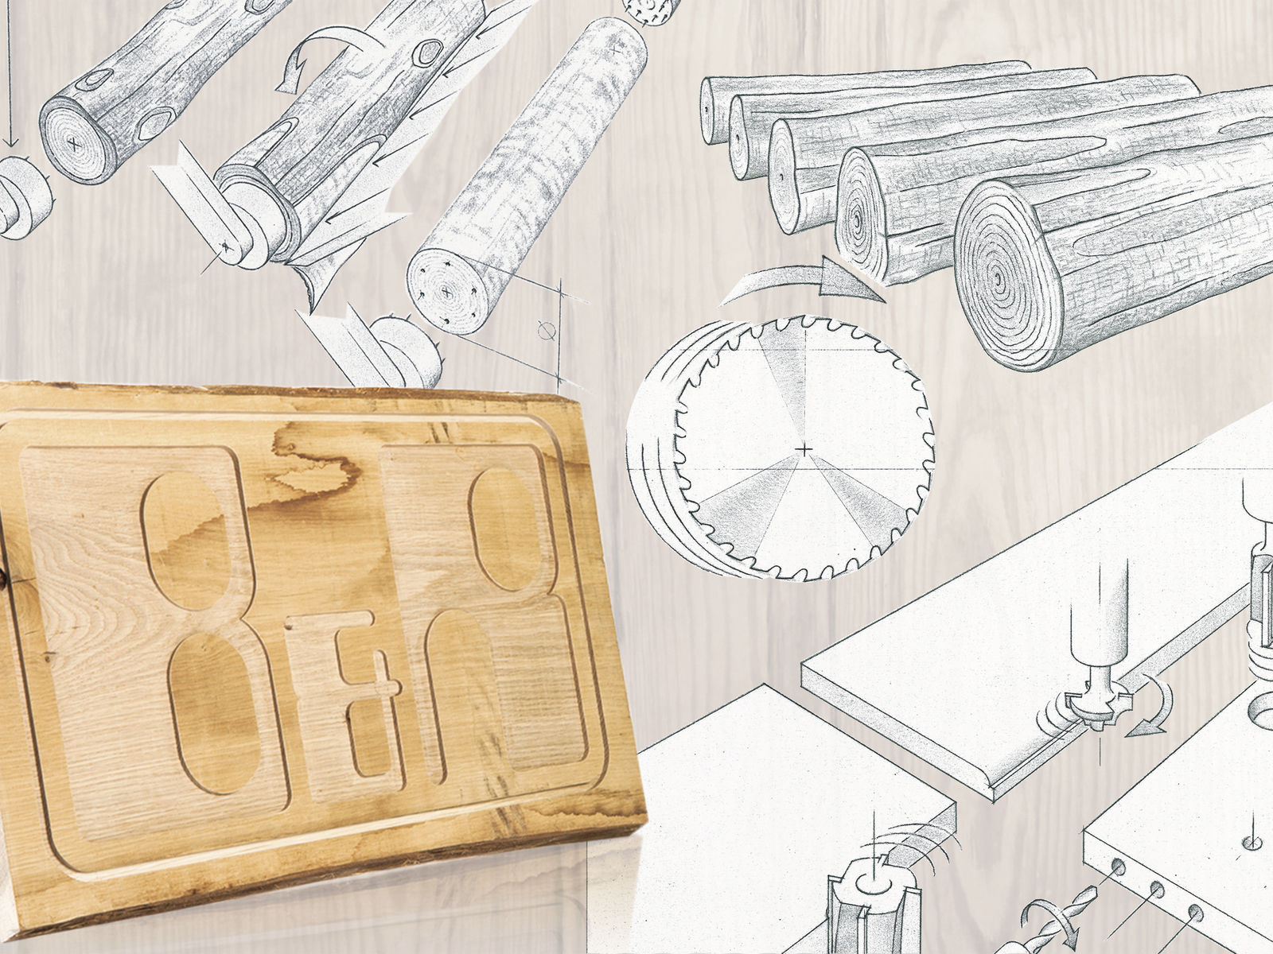
B&R will be showcasing its latest innovations for the wood industry at Ligna.

关于贝加莱
贝加莱是一家总部位于奥地利并在全球拥有分公司的创新型自动化企业。2017年7月，贝加莱成为ABB集团的机械自动化事业部。作为工业自动化领域的全球领导者，贝加莱将前沿技术与领先工程相结合，为几乎每个行业的客户提供面向机器与工厂自动化、运动控制、HMI和集成安全技术的完整解决方案。借助于OPC UA、POWERLINK、openSAFETY等工业物联网通信标准，以及强大的Automation Studio软件开发平台，贝加莱不断重新定义自动化工程的未来。受简化流程和超出客户预期的承诺驱动，贝加莱始终保持创新精神并处于工业自动化领域的前沿。
获取更多信息，请访问www.br-automation.com。

