Break free from hardwired safety
B&R makes programmable safety technology profitable for small applications
At the Hannover Messe, B&R presented a new series of safe digital mixed modules from its X20 SafeIO family – breaking down the barriers to entry for programmable safety technology. Even in the smallest applications, integrated safety technology is now no more expensive than a conventional relay solution.
B&R's commitment to absolute scalability is nothing new. From entry level to high end – all B&R products are fully interchangeable without having to make any major functional changes. The new mixed modules take scalability one step further on the low end of B&R's safety portfolio. Safety solutions on the smallest scale can now be implemented with a single X20 SafeIO module.
Wear-free semiconductors
B&R's programmable safety technology is based on semiconductor components that are not subject to wear like conventional electromechanical relays, which have to be replaced periodically to maintain the functionality of the safety application. Semiconductor-based safety technology is also considerably faster than relay-based solutions.

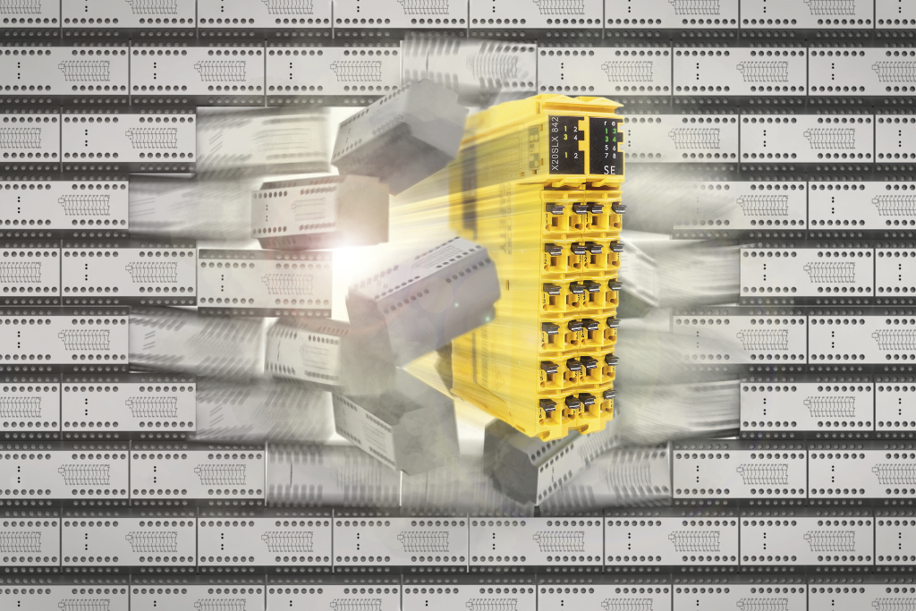
B&R's new digital mixed modules break through the cost barrier: Programmable safety technology is now no more expensive than a conventional relay solution.

About B&R
B&R, a division of ABB Group, is a global leader in industrial automation headquartered in Austria. B&R combines state-of-the-art technology with advanced engineering to provide customers in virtually every industry with complete solutions for machine and factory automation, motion control, HMI and integrated safety technology. With Industrial IoT communication standards including OPC UA, POWERLINK and openSAFETY as well as its Automation Studio software, B&R is constantly redefining the future of automation engineering. The innovative spirit that keeps B&R at the forefront of industrial automation is driven by a commitment to simplifying processes and exceeding customer expectations.
For more information, visit www.br-automation.com.

