reACTION: Turbo-charged safety technology
B&R presents reACTION technology for ultrafast safety applications
B&R is heralding a breakthrough in response times for safety technology. At the Hannover Messe, the automation specialists presented programmable safety technology with the world's fastest response times. reACTION technology achieves safety response times down to 100 microseconds.
With this advancement, B&R is extending the use of reACTION technology into the area of safety applications. This technology makes it possible for time-critical subprocesses to be executed directly in the I/O modules, which reduces response times by a factor of 100 or more. What's more, no expensive special hardware is needed to use reACTION technology, and programming is just as easy as it is for conventional control solutions.
Relief for controller and network
The reACTION module handles a portion of the processing, relieving both the controller and the network and in many cases allowing them to be scaled down. In most cases, the resulting savings more than outweigh the added cost of the reACTION modules.

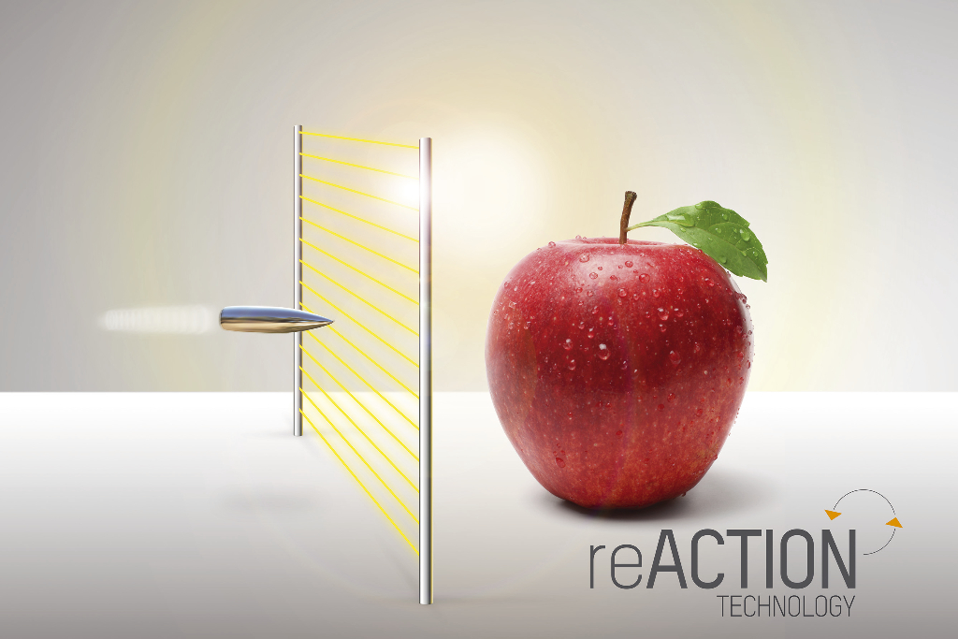
reACTION technology reduces response times in safety applications down to 100 microseconds.

About B&R
B&R, a division of ABB Group, is a global leader in industrial automation headquartered in Austria. B&R combines state-of-the-art technology with advanced engineering to provide customers in virtually every industry with complete solutions for machine and factory automation, motion control, HMI and integrated safety technology. With Industrial IoT communication standards including OPC UA, POWERLINK and openSAFETY as well as its Automation Studio software, B&R is constantly redefining the future of automation engineering. The innovative spirit that keeps B&R at the forefront of industrial automation is driven by a commitment to simplifying processes and exceeding customer expectations.
For more information, visit www.br-automation.com.

