Real Time Ethernet Conference in Bangalore
The open source future of deterministic industrial automation
The Real Time Ethernet Conference brought industry experts from Accenture, Bharat Electronics Limited, ABB, Robert Bosch Engineering Services, Barry Wehmiller International and more to Bangalore, India to discuss how real-time determinism can be achieved over standard Ethernet using a vendor-independent, open source approach – a crucial requirement for Industry 4.0 automation. Event partners Kalycito, Altera, B&R and the Ethernet POWERLINK Standardization Group presented on topics ranging from the basics of POWERLINK implementation to its usage in high-performance automation applications.
Easy implementation of POWERLINK communication
Srinivasan Subramani, project manager for embedded systems at Barry Wehmiller International, reported on his experience with the open source POWERLINK stack: "The protocol was very easy to implement, and it took us just two days of training to establish POWERLINK communication with a com-pletely real-time deterministic response."
Free choice of hardware and software
Open technologies specialist Ninad Deshpande adds: "The reign of proprietary systems for industrial electronics is over. Openness and real vendor-independence make it easy for device manufacturers to integrate POWERLINK cheaply and easily. They enjoy completely flexible implementation with a free choice of hardware and software at their disposal." In less than a decade, Ethernet POWERLINK has created a strong foothold in the Indian market with more than 100,000 installed nodes.

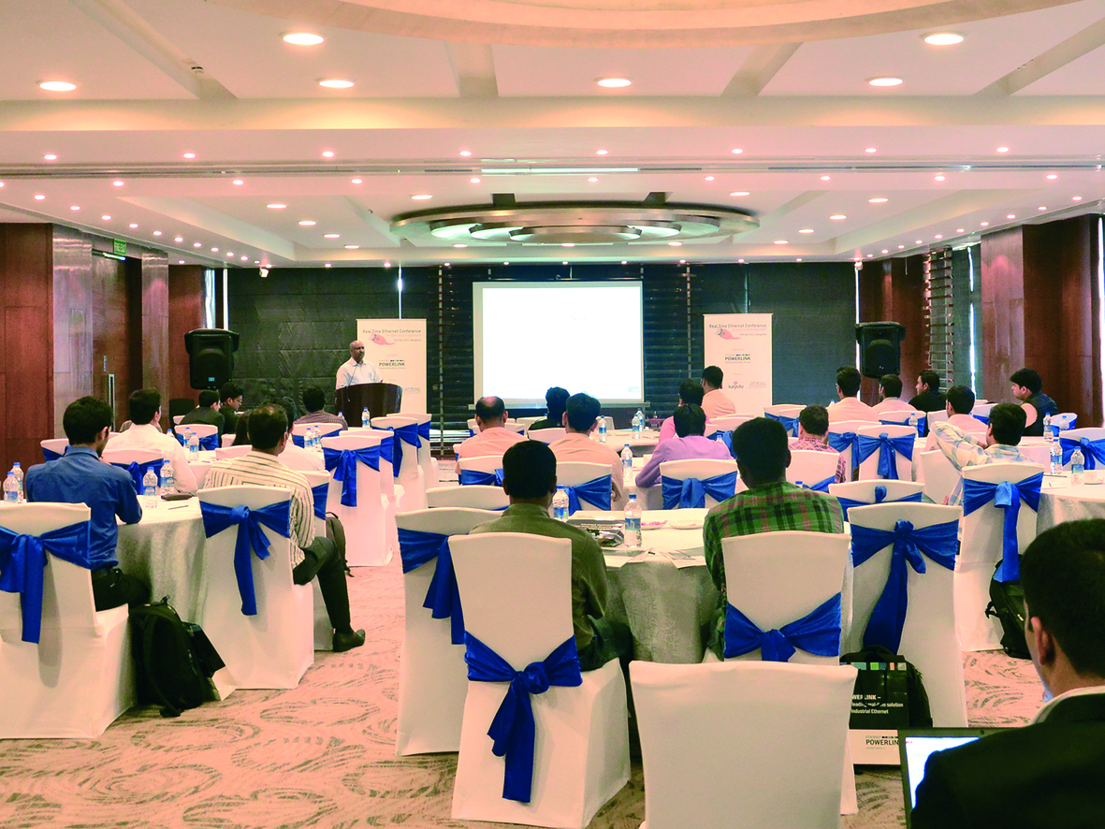
Real Time Ethernet Conference held in partnership between Altera, Kalycito and B&R in association with the Ethernet POWERLINK Standardization Group.

About B&R
B&R, a division of ABB Group, is a global leader in industrial automation headquartered in Austria. B&R combines state-of-the-art technology with advanced engineering to provide customers in virtually every industry with complete solutions for machine and factory automation, motion control, HMI and integrated safety technology. With Industrial IoT communication standards including OPC UA, POWERLINK and openSAFETY as well as its Automation Studio software, B&R is constantly redefining the future of automation engineering. The innovative spirit that keeps B&R at the forefront of industrial automation is driven by a commitment to simplifying processes and exceeding customer expectations.
For more information, visit www.br-automation.com.

