Hygienic connections
B&R streamlines IP69K connectivity
Stainless steel motors from B&R meet strict hygienic design standards and are now easier than ever to use. Employing a special connector, the motor can be connected and disconnected in the field. This connector meets the same strict hygienic design standards as the previous variant with a fixed mounted cable.
The new connector technology makes the motors much easier to work with and allows the machine to be cabled as usual, even in areas with heightened hygienic requirements. This also has numerous advantages when it comes to maintenance. Damaged cables can simply be unplugged and replaced without having to change out the entire motor.
IP69K connector
The connectors were designed according to the same strict hygienic standards as the motors. They have an IP69K rating and meet EHEDG, 3A and FDA hygiene standards. The hybrid cables with FDA approval and heat resistance up to 150°C exhibit a high standard of safety and reliability and therefore fit seamlessly into the B&R environment. Using the hybrid motor cable saves both time and money.

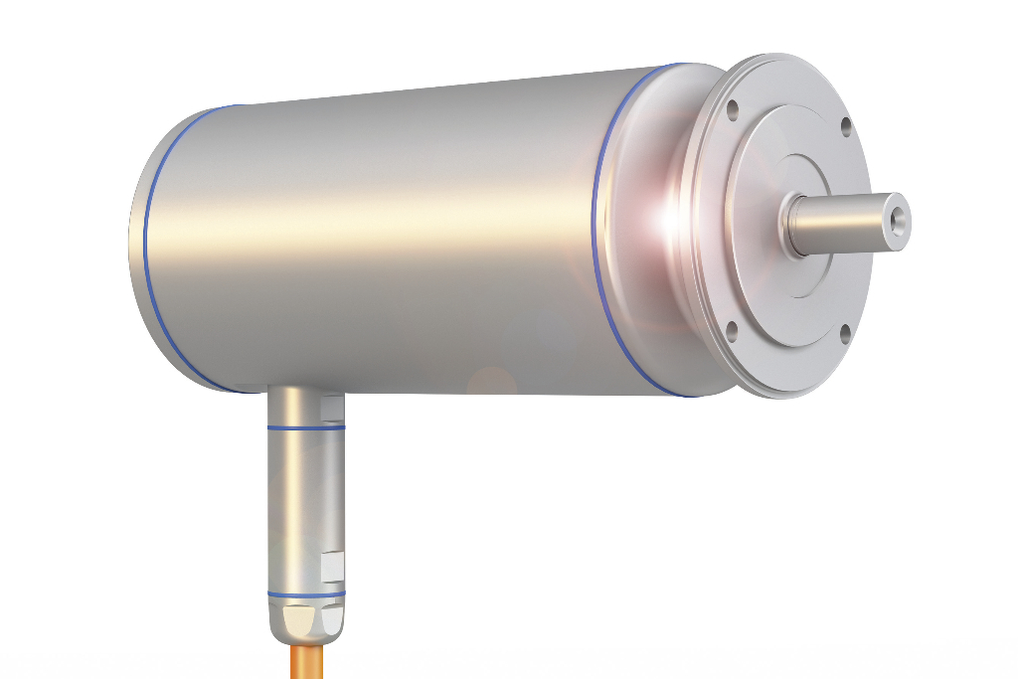
Installation and maintenance of hygienically designed motors is considerably simplified thanks to the IP69k-rated connector.

About B&R
B&R, a division of ABB Group, is a global leader in industrial automation headquartered in Austria. B&R combines state-of-the-art technology with advanced engineering to provide customers in virtually every industry with complete solutions for machine and factory automation, motion control, HMI and integrated safety technology. With Industrial IoT communication standards including OPC UA, POWERLINK and openSAFETY as well as its Automation Studio software, B&R is constantly redefining the future of automation engineering. The innovative spirit that keeps B&R at the forefront of industrial automation is driven by a commitment to simplifying processes and exceeding customer expectations.
For more information, visit www.br-automation.com.

