Pneumatic system solutions with B&R
POWERLINK enables seamless integration of valve terminals
In cooperation with partners Festo, ASCO Numatics and Aventics, B&R has created the perfect solution for seamlessly integrating pneumatic solutions in an automation system. Customers benefit from extremely easy handling, high clock accuracy throughout the system and maximum freedom in the selection of hardware.
Valve terminal families can easily be integrated in the B&R engineering environment using a device description file. Proven functionalities – graphical display, simple component configuration, automatic firmware downloads and easy-to-use diagnostics features – are available for valve terminals just as they are available for other B&R products. This shortens commissioning times, maximizes system performance and productivity, and reduces downtime to an absolute minimum.
Fast response times
One of the things that characterizes the POWERLINK communication protocol is its high performance in terms of cycle time and clock accuracy. The integration of pneumatic solutions into the B&R automation system allows high-speed response times in the field of pneumatics as well. Mechanical sequences can be more precisely coordinated, opening up entirely new concepts in machine design.

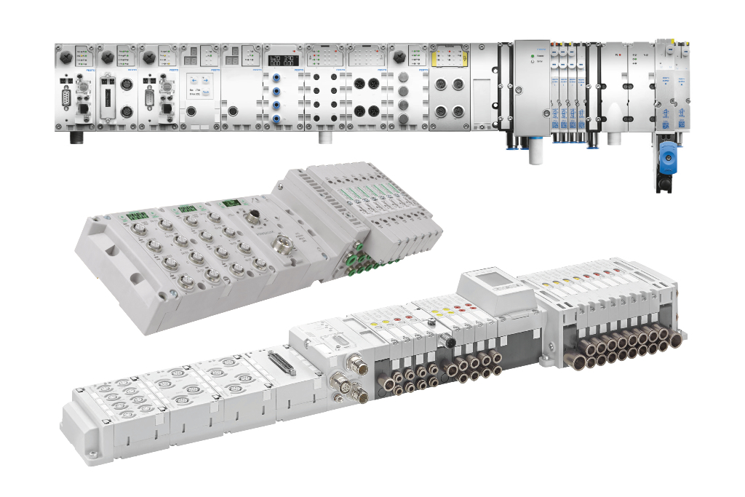
Valve terminals from Festo, ASCO, Numatics and Aventics can be seamlessly integrated in B&R automation solutions using POWERLINK.

About B&R
B&R, a division of ABB Group, is a global leader in industrial automation headquartered in Austria. B&R combines state-of-the-art technology with advanced engineering to provide customers in virtually every industry with complete solutions for machine and factory automation, motion control, HMI and integrated safety technology. With Industrial IoT communication standards including OPC UA, POWERLINK and openSAFETY as well as its Automation Studio software, B&R is constantly redefining the future of automation engineering. The innovative spirit that keeps B&R at the forefront of industrial automation is driven by a commitment to simplifying processes and exceeding customer expectations.
For more information, visit www.br-automation.com.

