10,000 COMAU robots controlled by B&R
Comau and B&R celebrate a productive partnership with a promising future
As the collaboration between COMAU Robotics and B&R continues to mature and expand, the companies can already boast ten thousand units installed and operating all around the globe. This achievement underscores the quality of COMAU products, which rely on powerful, accurate and reliable control electronics from automation specialist B&R.
The two companies have been working for years to revolutionize the integration of robotics into production lines. OEMs and end users benefit from excellent synchronization and the resulting responsiveness of the combined system.
"This is the concrete result of an intense collaboration that has allowed both companies to become key players in the market, with the aim to continuously improve in technologies and grow in new market sectors," says Tobias Daniel, Head of Robotics Europe and Americas at COMAU.
"We are pleased to say that this cooperation is yielding tangible results on a growing market," says Walter Burgstaller, B&R's European sales director. "More and more companies are looking to robotics as a means to optimize production and respond to the ever increasing flexibility and complexity of their plants."

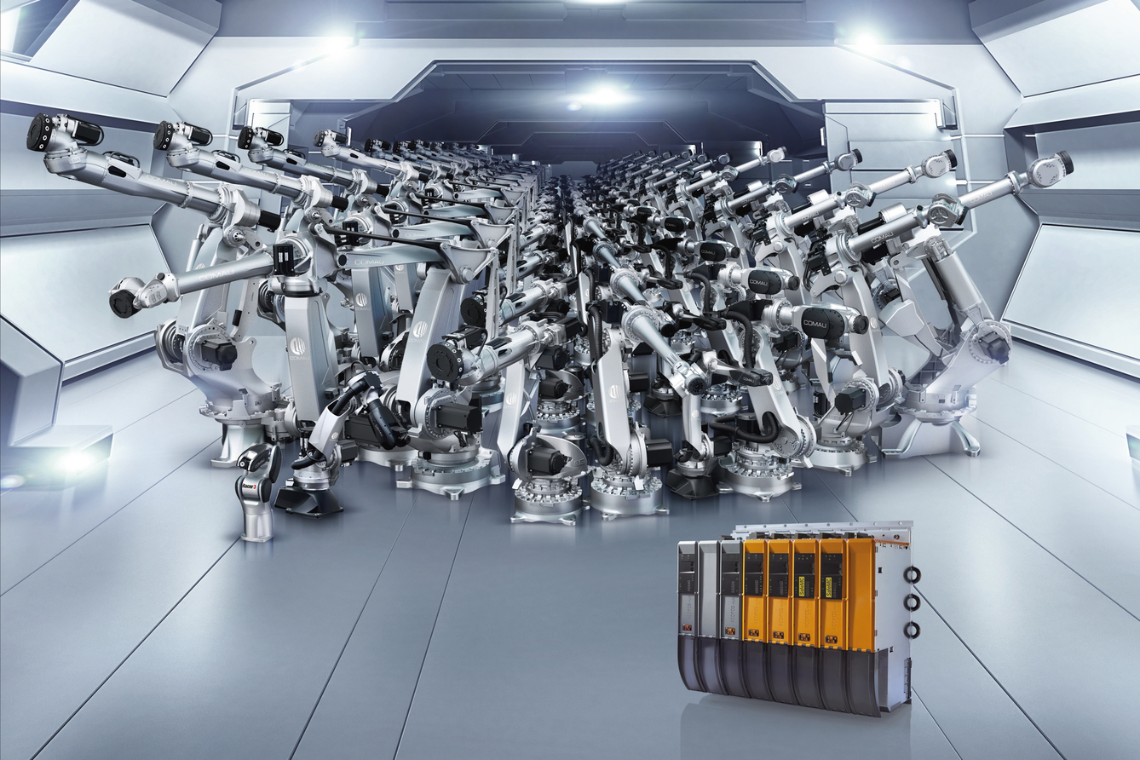
10,000 COMAU robots have been equipped with B&R control technology.

About B&R
B&R, a division of ABB Group, is a global leader in industrial automation headquartered in Austria. B&R combines state-of-the-art technology with advanced engineering to provide customers in virtually every industry with complete solutions for machine and factory automation, motion control, HMI and integrated safety technology. With Industrial IoT communication standards including OPC UA, POWERLINK and openSAFETY as well as its Automation Studio software, B&R is constantly redefining the future of automation engineering. The innovative spirit that keeps B&R at the forefront of industrial automation is driven by a commitment to simplifying processes and exceeding customer expectations.
For more information, visit www.br-automation.com.

