Perfectly synchronized
B&R fuses material handling and production
Automation technology from B&R makes it easy to achieve precise synchronization of conveyor belts and robots. The company's readily configurable PLCopen function blocks can be used to implement conveyor belt tracking.
An increasing number production line processes require synchronization with conveyor belts. Achieving the levels of precision and speed needed for these processes used to require a highly complex control solution. The advantage of conveyor belt tracking is that, since the production line never comes to a stop, it can achieve higher production volumes.
Fully integrated robotics
The complexity of these systems is constantly increasing, with the presence of robots becoming more and more common. Their tasks range from simple sorting to complex product processing on running conveyor belts. PLCopen function blocks from B&R can be used for all types of robot kinematics and even allow robots to be synchronized with multiple conveyor belts. The interfaces are also ideally suited for integrating HMI applications for all types of kinematic systems.
The robot can move freely during the synchronization phase, which also enables complex product manipulation. A special feature of the B&R solution is that the conveyor belt is fully integrated in the application. An external sensor that supplies information about the current position of the conveyor belt is all that is needed.
Hardware-independent
The conveyor belt tracking solution from B&R is hardware-independent, which allows the use of different drive systems with different kinematics. The application can be created quickly and easily upgraded at a later time. The robot can be replaced or the conveyor belts can be upgraded at any time without a significant amount of new development work. The majority of the software can be used as-is without any changes at all.

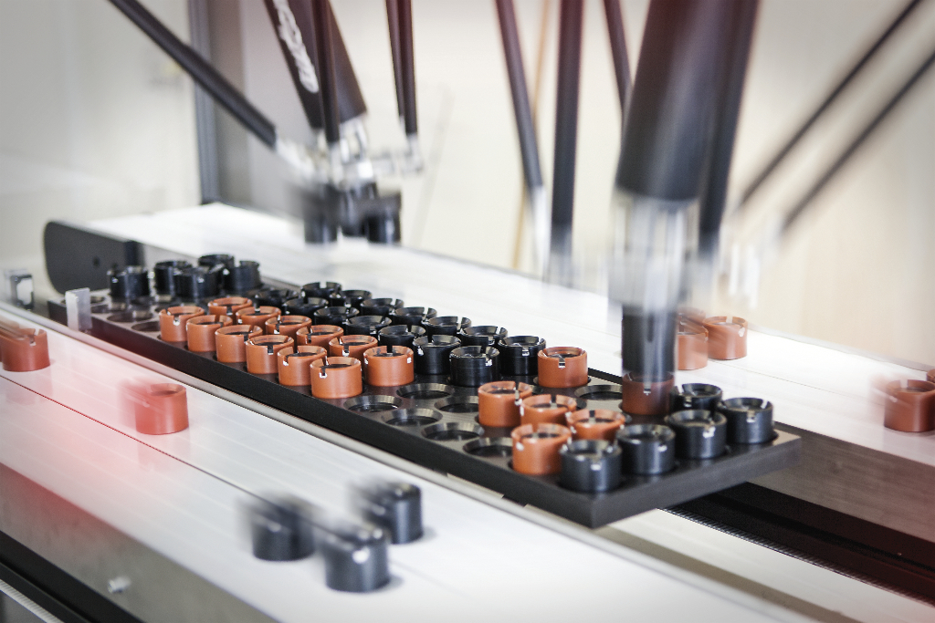
B&R makes it easy to synchronize robots and conveyor belts.

About B&R
B&R, a division of ABB Group, is a global leader in industrial automation headquartered in Austria. B&R combines state-of-the-art technology with advanced engineering to provide customers in virtually every industry with complete solutions for machine and factory automation, motion control, HMI and integrated safety technology. With Industrial IoT communication standards including OPC UA, POWERLINK and openSAFETY as well as its Automation Studio software, B&R is constantly redefining the future of automation engineering. The innovative spirit that keeps B&R at the forefront of industrial automation is driven by a commitment to simplifying processes and exceeding customer expectations.
For more information, visit www.br-automation.com.

