Audit trails made easy
New mapp component for implementing applications in compliance with 21 CFR Part 11
B&R has added an audit trail component to its mapp technology portfolio. For applications subject to the FDA's Title 21 CFR Part 11 requirements, this means both accelerated development and reduced investment risk. The ability to retrace actions performed on a machine can also be of great service to its manufacturer in the event of warranty claims.
Companies in the food and pharmaceutical industries need the ability to log operations performed by users seamlessly and without risk of tampering. The new mapp Audit component is quick and easy way to implement and customize the necessary audit trail. mapp Audit runs directly in the automation system. System manufacturers and end users benefit from maximum security without having to implement organizational measures to prevent tampering on the control system.
Automatic data exchange
There is no need to write a program for the audit trail function; all that is needed is to configure the machine-specific parameters. mapp Audit automatically retrieves the information it needs about the operator from the mapp User component using the client-server principle. Audit trail data is stored in memory with a checksum mechanism for tamper resistance. The data can be output in an encrypted file or viewed on the HMI screen using the integrated mapp Audit visualization.
Warranty claim justified?
mapp Audit offers benefits for other industries as well. It enables manufacturers of all types of machinery and equipment to review operator activity in order to determine whether a system has been used appropriately. It is equally possible to determine whether equipment has been used outside the specified operating times – an indication that employees are engaging in unauthorized production for their own profit.

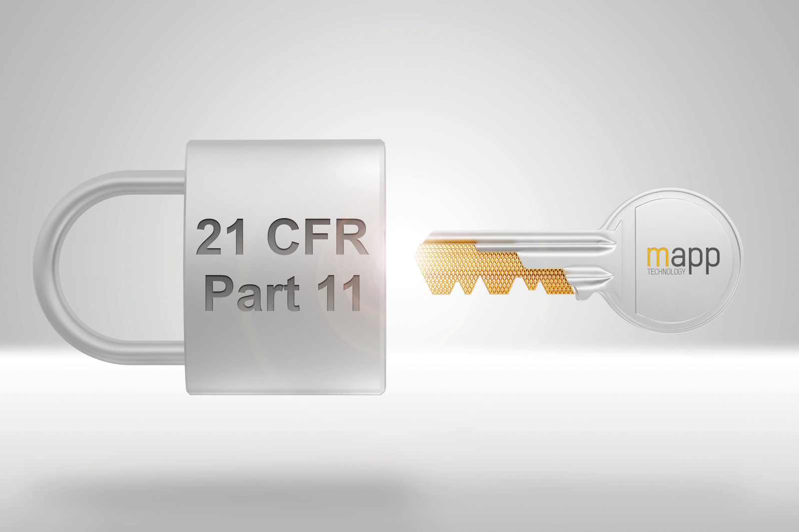
Applications subject to the FDA's Title 21 CFR Part 11 requirements can be developed faster and with less investment risk using mapp Audit.

About B&R
B&R, a division of ABB Group, is a global leader in industrial automation headquartered in Austria. B&R combines state-of-the-art technology with advanced engineering to provide customers in virtually every industry with complete solutions for machine and factory automation, motion control, HMI and integrated safety technology. With Industrial IoT communication standards including OPC UA, POWERLINK and openSAFETY as well as its Automation Studio software, B&R is constantly redefining the future of automation engineering. The innovative spirit that keeps B&R at the forefront of industrial automation is driven by a commitment to simplifying processes and exceeding customer expectations.
For more information, visit www.br-automation.com.

