Audit trails made easy
New mapp component for implementing applications in compliance with 21 CFR Part 11
B&R has added an audit trail component to its mapp technology portfolio. For applications subject to the FDA's Title 21 CFR Part 11 requirements, this means both accelerated development and reduced investment risk. The ability to retrace actions performed on a machine can also be of great service to its manufacturer in the event of warranty claims.
Companies in the food and pharmaceutical industries need the ability to log operations performed by users seamlessly and without risk of tampering. The new mapp audit component is quick and easy way to implement and customize the necessary audit trail.
Automatic data exchange
There is no need to write a program for the audit trail function; all that is needed is to configure the machine-specific parameters. mapp audit automatically retrieves the information it needs about the operator from the mapp user component using the client-server principle. Audit trail data is stored in memory with a checksum mechanism for tamper resistance. The data can be output in an encrypted file or viewed on the HMI using the integrated mapp audit visualization.
Warranty claim justified?
mapp audit offers benefits for other industries as well. It enables manufacturers of all types of machinery and equipment to review operator activity in order to determine whether a system has been used appropriately. It is equally possible to determine whether equipment has been used outside the specified operating times – an indication that employees are engaging in unauthorized production for their own profit.

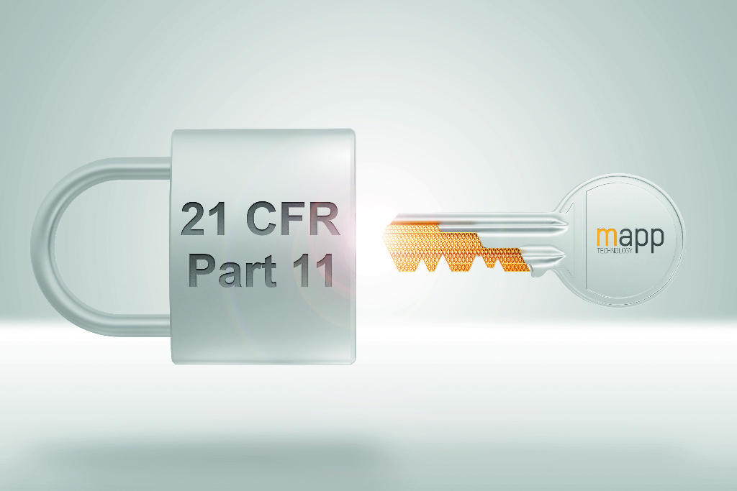
For applications subject to the FDA's Title 21 CFR Part 11 requirements, the mapp audit component means both accelerated development and reduced investment risk.

A proposito di B&R
B&R, una divisione del Gruppo ABB, è leader globale nell'automazione industriale con sede in Austria. B&R combina tecnologia all'avanguardia con ingegneria avanzata per fornire ai clienti, praticamente di ogni settore, soluzioni complete per l'automazione di macchine e fabbriche, controllo del movimento, HMI e tecnologia di sicurezza integrata. Con gli standard di comunicazione IoT industriale tra cui OPC UA, POWERLINK e openSAFETY, nonché il software Automation Studio, B&R ridefinisce costantemente il futuro dell'ingegneria dell'automazione. Lo spirito innovativo che mantiene B&R all'avanguardia nell'automazione industriale è guidato dall'impegno a semplificare i processi e a superare le aspettative dei clienti.
Per maggiori informazioni, visita www.br-automation.com

