Dust-proof production and operation
B&R to present new dust and lint resistant panels at ITMA in Milan
Dust and lint pose a great challenge for textile production machinery. From November 12 - 19 at the ITMA trade show in Milan, Italy (Hall 8, Booth 9), B&R will present a new generation of modular swing arm panels with IP65 protection. With this, machines can be operated easily and reliably – even in dusty environments. In addition to the new operator terminals, B&R will also exhibit I/O systems, safety technology and drive technology featuring IP65 and IP67 protection.
Synchronous despite power failure
A broken thread can be time-consuming and costly. B&R offers a selection of preprogrammed technology packages, including one that provides highly precise winder control at high speeds. Additionally, B&R drives maintain synchronization when shutting down following a power failure and thus prevent the thread from tearing. This makes it easier to get the system back up and running with minimal downtime.
Condition monitoring made easy
To help maximize productivity, B&R offers ready-to-use solutions for process data acquisition, condition monitoring and energy monitoring. This means maintenance cycles and energy consumption can be optimized, for example. The availability of machines and systems in the textile branch is raised significantly.

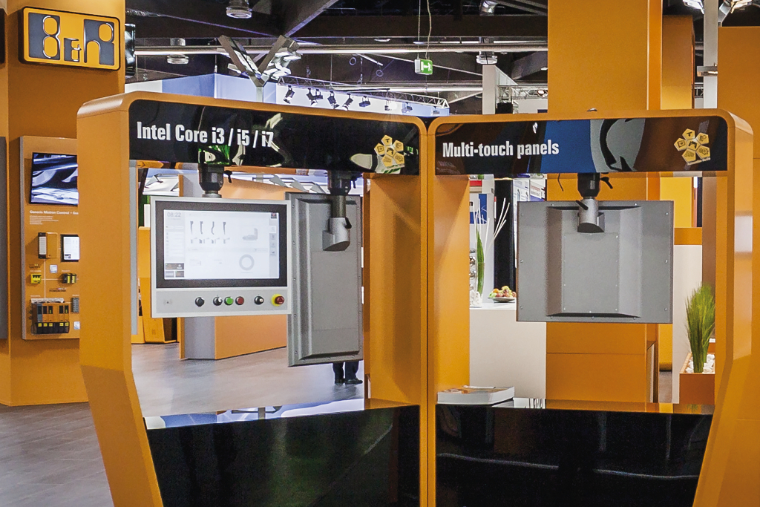
At the ITMA trade show, B&R will exhibit dust and lint resistant operator terminals as well as numerous other products with IP65 and IP67 protection.

About B&R
B&R, a division of ABB Group, is a global leader in industrial automation headquartered in Austria. B&R combines state-of-the-art technology with advanced engineering to provide customers in virtually every industry with complete solutions for machine and factory automation, motion control, HMI and integrated safety technology. With Industrial IoT communication standards including OPC UA, POWERLINK and openSAFETY as well as its Automation Studio software, B&R is constantly redefining the future of automation engineering. The innovative spirit that keeps B&R at the forefront of industrial automation is driven by a commitment to simplifying processes and exceeding customer expectations.
For more information, visit www.br-automation.com.

