Precise strain measurement
B&R introduces X20 modules for strain gauges
B&R has added 2 new analog input modules to its X20 I/O series that can be used to digitize signals from strain gauges: the X20AIA744 with 2 full-bridge strain gauge inputs and the X20AIB744 with 4 full-bridge strain gauge inputs. Up to 4 strain gauge channels can now be housed in a module just as thin as a single-channel unit. Users save both equipment costs and control cabinet space.
The X20AIA744 and X20AIB744 modules work with 4-wire strain gauge load cells. Compensation in the measurement system eliminates absolute uncertainty in the measurement circuit, such as component tolerances, effective bridge voltage or zero offset. The modules each have 24-bit converter resolution.

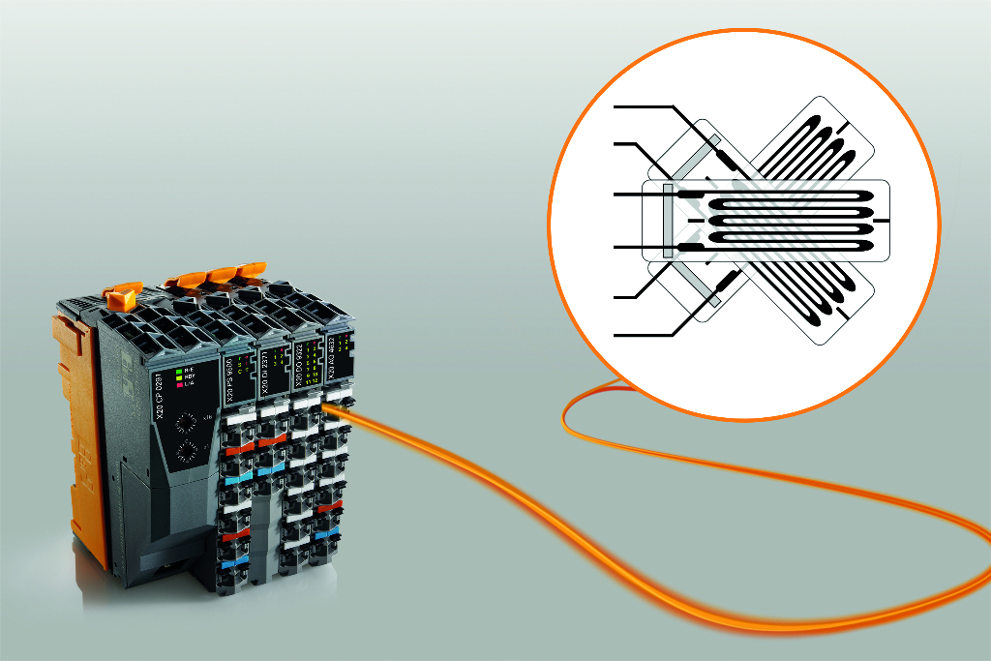
Two new X20 modules are now available for digitizing strain gauge signals.

About B&R
B&R, a division of ABB Group, is a global leader in industrial automation headquartered in Austria. B&R combines state-of-the-art technology with advanced engineering to provide customers in virtually every industry with complete solutions for machine and factory automation, motion control, HMI and integrated safety technology. With Industrial IoT communication standards including OPC UA, POWERLINK and openSAFETY as well as its Automation Studio software, B&R is constantly redefining the future of automation engineering. The innovative spirit that keeps B&R at the forefront of industrial automation is driven by a commitment to simplifying processes and exceeding customer expectations.
For more information, visit www.br-automation.com.

