B&R opens new office in Košice
Eastern Slovakia to benefit from strengthened local support and training
B&R customers around the world benefit from its global network of local sales and support teams. To extend the capabilities of B&R Slovakia, with existing headquarters in Nové Mesto nad Váhom, B&R has opened a new office in Košice. Customers in Eastern Slovakia, primarily in the automotive, food and beverage and packaging industries, will enjoy faster, more personalized local service.
"Our customers recognize the benefits in flexibility and efficiency that come with our innovative, high-quality solutions," says regional sales manager Martin Majer. "Yet 'Perfection in Automation' means more than simply developing quality products that meet industry requirements. It means understanding the specific needs of the region, the country and really each person with whom we come in contact."
Supporting the customer
The new office will provide fast, high-quality support for B&R hardware and software, as well as offering training courses. The sales team will be able to reach out to new customers while helping existing customers accelerate the entire design and development process and get their machinery and equipment to market faster.

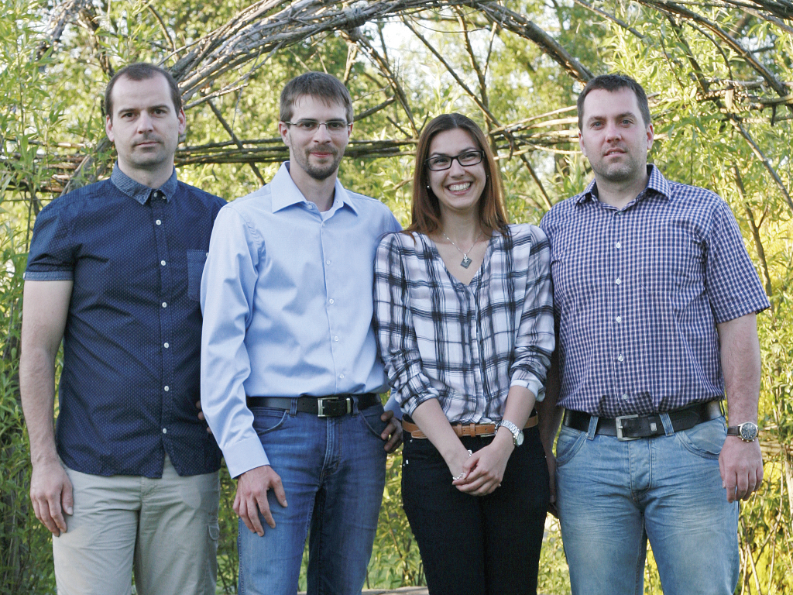
Sales Office Manager Martin Majer (2nd from the left) leads the new office in Košice.

About B&R
B&R, a division of ABB Group, is a global leader in industrial automation headquartered in Austria. B&R combines state-of-the-art technology with advanced engineering to provide customers in virtually every industry with complete solutions for machine and factory automation, motion control, HMI and integrated safety technology. With Industrial IoT communication standards including OPC UA, POWERLINK and openSAFETY as well as its Automation Studio software, B&R is constantly redefining the future of automation engineering. The innovative spirit that keeps B&R at the forefront of industrial automation is driven by a commitment to simplifying processes and exceeding customer expectations.
For more information, visit www.br-automation.com.

