Smart factories and bright prospects
Automation specialist B&R anticipates double-digit growth
B&R continues its long track record of growth. For the current year, the company again anticipates a double-digit increase in revenue. This was announced by general manager Peter Gucher at B&R's press conference in Salzburg. In addition to solid growth in all existing markets, the company's entry into the field of factory automation delivered a significant boost in turnover.
Based on the year so far, Gucher expects an increase of between 11 and 14%, explaining that general economic uncertainties – in China and elsewhere – render it difficult to make the forecast as precise as he has in previous years.
B&R's own smart factory
The relatively new market of factory automation accounts for an increasing share of the company's revenue. "We've been running our own fully networked smart factory for years now, and we're expanding on our solutions all the time. Our customers certainly benefit from this as well," says Gucher.
Mass customization – Batch size 1
With its PCs and HMI panels alone, B&R offers its customers more than 2 billion theoretically possible combinations to choose from in its online configuration tool. Based on the selected configuration, B&R's ERP automatically organizes the production of each item – down to a batch size of one. "In 2014 we produced 175,000 PCs and panels this way, and we expect that number to be even higher in 2015, particularly for products with multi-touch displays," says Gucher.
Highlights – SPS IPC Drives
B&R will be presenting the next dimension of its mapp software platform at the SPS IPC Drives. With mapp View, B&R now offers direct access to the wide world of web technology right from the engineering software. For the first time, automation engineers have all the tools they need to create powerful and intuitive HMI solutions – and they don't have to be an expert web developer to do it.
Other innovations include service-friendly HMI for the automotive industry and a new class of extremely compact and high-performance controllers. With the Automation Panel 5000, B&R will also be presenting a new generation of swing-arm-mounted operator panels.

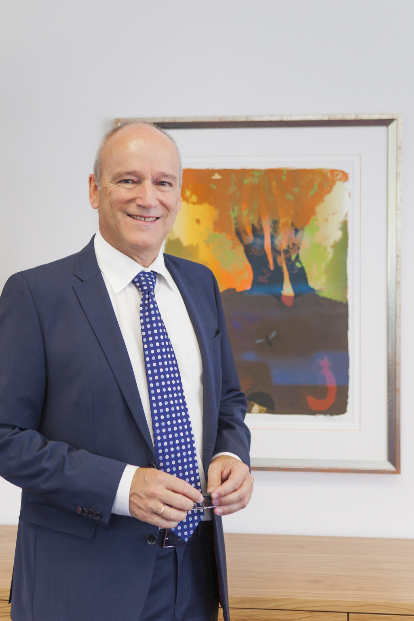
"B&R's solutions for factory automation accelerate the practical implementation of Industry 4.0 requirements," says Peter Gucher, General Manager at B&R.

About B&R
B&R, a division of ABB Group, is a global leader in industrial automation headquartered in Austria. B&R combines state-of-the-art technology with advanced engineering to provide customers in virtually every industry with complete solutions for machine and factory automation, motion control, HMI and integrated safety technology. With Industrial IoT communication standards including OPC UA, POWERLINK and openSAFETY as well as its Automation Studio software, B&R is constantly redefining the future of automation engineering. The innovative spirit that keeps B&R at the forefront of industrial automation is driven by a commitment to simplifying processes and exceeding customer expectations.
For more information, visit www.br-automation.com.

