Boost in efficiency for wind power
EWEA: B&R safety technology saves up to 50%
At the EWEA trade show in Paris, France, B&R will present integrated safety technology that allows operators of wind turbines to save 30 to 50% in costs for safety systems. From November 17 - 20 at Booth S13, the automation specialist will demonstrate how field deployment of service technicians will be reduced to a minimum thanks to remote maintenance solutions.
A special interface even makes it possible to acknowledge errors critical to safety functionality. This not only eliminates the need for field service deployment, but significantly increases system availability. It is also possible to perform comprehensive remote diagnostics on the safety application.
Easier on the equipment
B&R safety technology is completely integrated in the automation solution, giving it full access to data from the functional application. This allows safety reactions to be tailored to specific events and minimizes the strain on the mechanical equipment.

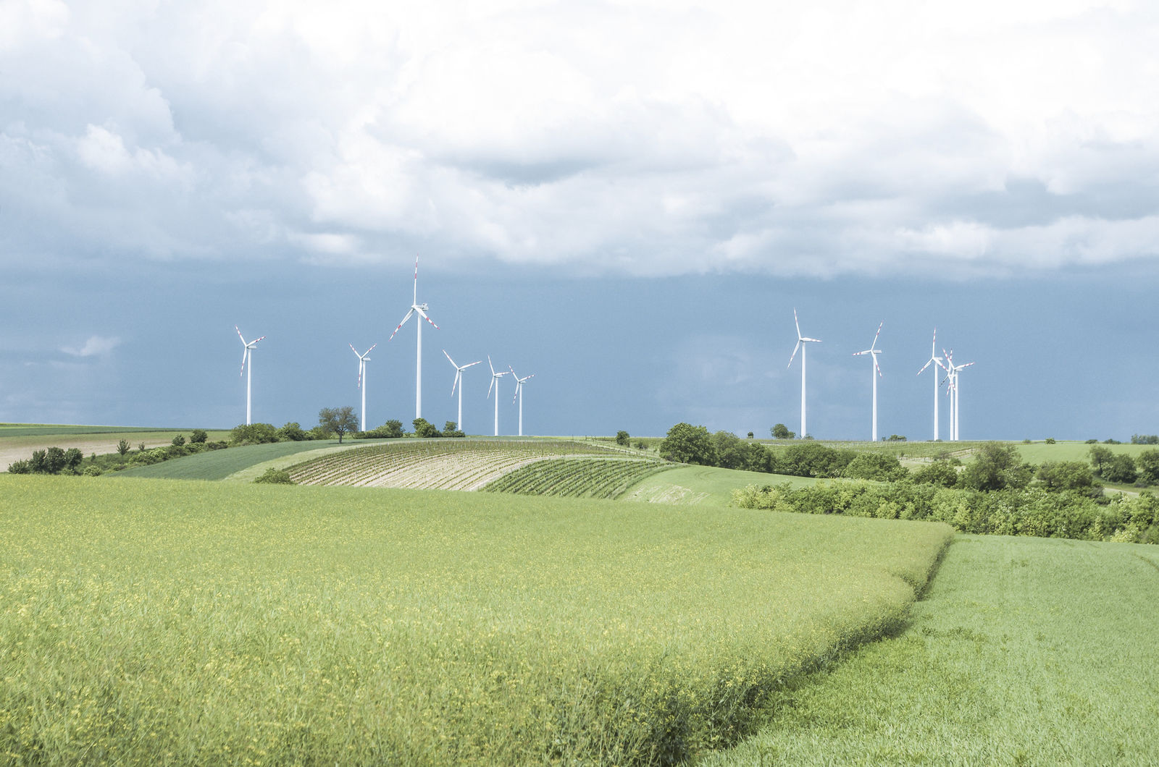
B&R will exhibit modern safety concepts for wind turbines at the EWEA trade show.

About B&R
B&R, a division of ABB Group, is a global leader in industrial automation headquartered in Austria. B&R combines state-of-the-art technology with advanced engineering to provide customers in virtually every industry with complete solutions for machine and factory automation, motion control, HMI and integrated safety technology. With Industrial IoT communication standards including OPC UA, POWERLINK and openSAFETY as well as its Automation Studio software, B&R is constantly redefining the future of automation engineering. The innovative spirit that keeps B&R at the forefront of industrial automation is driven by a commitment to simplifying processes and exceeding customer expectations.
For more information, visit www.br-automation.com.

