Maximum scalability for agricultural machinery
B&R presents Scalability+ at the Agritechnica in Hanover
B&R's booth at Agritechnica, which is being held November 8-14 in Hanover, will showcase the automation specialist's innovative Scalability+ solutions. At Booth H05 in Hall 15, the company will show how agricultural automation can benefit from a complete hardware portfolio, ready-made software modules and a powerful development tool.
Scalability+ builds on the idea of integrated automation – the seamless interaction between controllers, terminals, power electronics, safety and sensors. Because the hardware is interchangeable in nearly all situations, the customer has the freedom to pick the appropriate hardware for their application. To effectively network the automation components, B&R relies on the Ethernet-based real-time POWERLINK protocol in addition to proven CAN bus technology.
Low investment risk
All B&R products are engineered, diagnosed and maintained using the Automation Studio software development tool. The software is independent of the hardware, so a high level of reusability is guaranteed. The user can, for example, replace a controller with a powerful industrial PC without having to make any changes to the software.
B&R also provides ready-made software components that implement basic functions without any programming. This allows programmers to focus on implementing features that represent added value for end users. B&R customers can bring new innovations to market faster and with less risk.

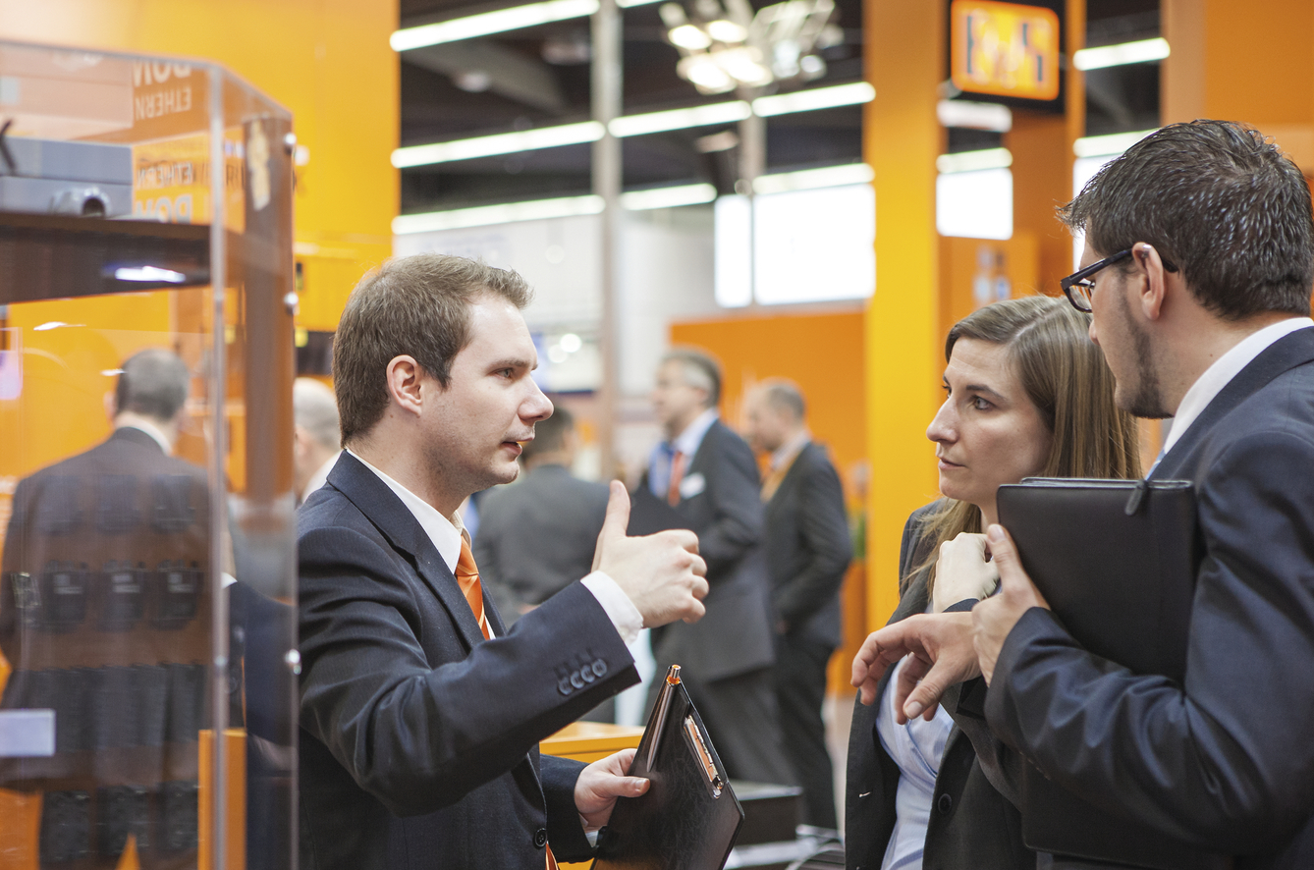
The B&R booth at the Agritechnica will showcase Scalability+.

About B&R
B&R, a division of ABB Group, is a global leader in industrial automation headquartered in Austria. B&R combines state-of-the-art technology with advanced engineering to provide customers in virtually every industry with complete solutions for machine and factory automation, motion control, HMI and integrated safety technology. With Industrial IoT communication standards including OPC UA, POWERLINK and openSAFETY as well as its Automation Studio software, B&R is constantly redefining the future of automation engineering. The innovative spirit that keeps B&R at the forefront of industrial automation is driven by a commitment to simplifying processes and exceeding customer expectations.
For more information, visit www.br-automation.com.

