Armed for any application
Fully enclosed, flexible and modular: B&R presents the Automation Panel 5000
At this year's SPS IPC Drives trade fair, B&R is introducing a new generation of swing arm operator panels that raise the bar when it comes to flexibility and modularity. Fully enclosed Automation Panel 5000 systems have IP65 protection and are available in many different variants.
These B&R Automation Panels allow either pendant or pedestal mounting and can be changed directly on-site. In addition, the panels are cabled through the swing arm using inexpensive standard cables. This is even possible with installed panels since all elements are easy to access. Cabling becomes even easier when using Smart Display Link 3 thanks to the slim RJ45 connector. Up to 100 meters can be spanned between the PC and the panel.
Easy to operate
These swing arm systems can be equipped with buttons, selector switches, key switches and an integrated E-stop button. Thanks to an integrated RFID reader, individual access rights can be assigned to anyone from service engineers to system operators. To adapt optimally to the needs of each machine, keys and switches can be customized and arranged according to customer specifications. A special module even allows custom keypads to be added on-site.
Quad-core performance on the swing arm
Automation Panel 5000 systems with multi-touch widescreen panels are available in sizes ranging from 15.6" to 24" with either HD Ready or Full HD resolution. A 21.5" variant in portrait format is also available. This is in addition to device variants with a 4:3 aspect ratio and analog resistive touch screen. All Automation Panel 5000 systems can be used either as a remote terminal or a full-fledged panel PC with quad-core performance.

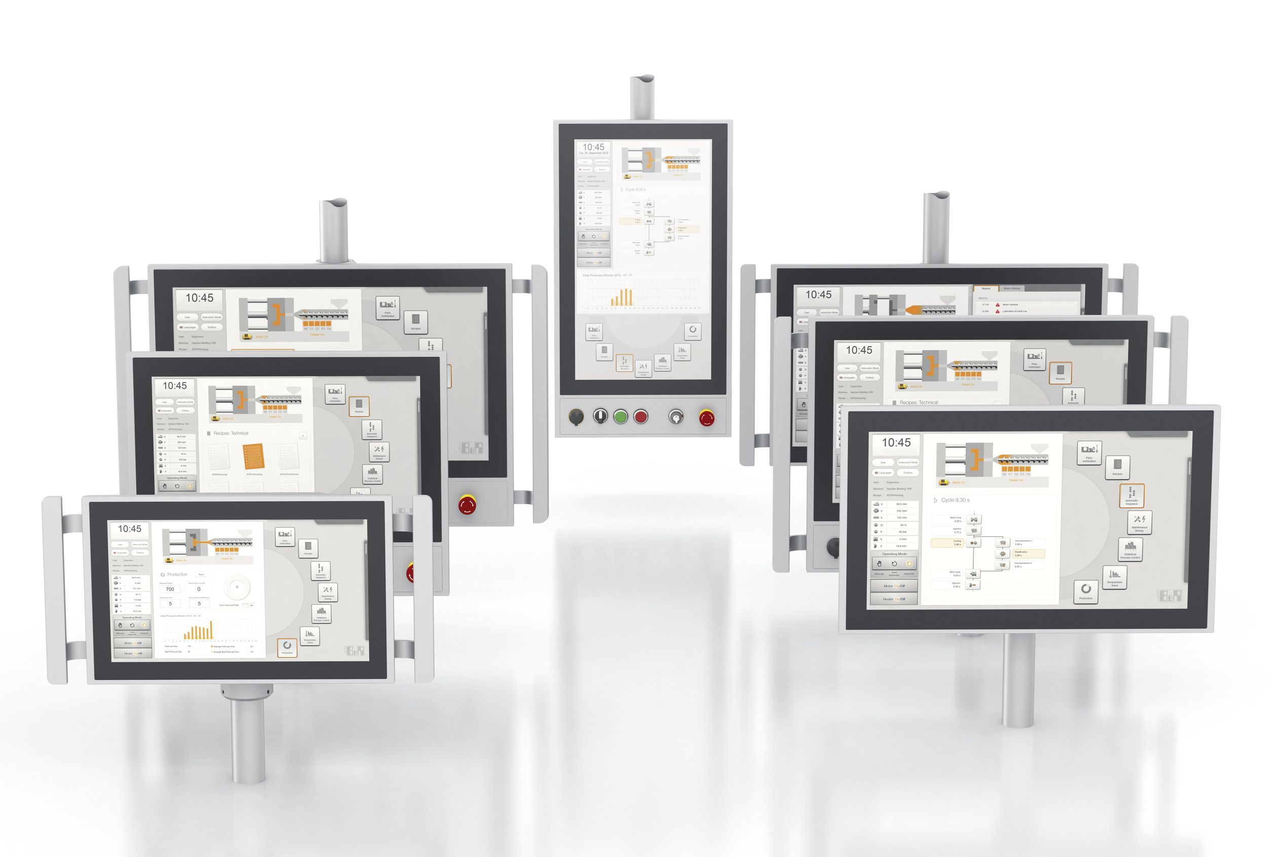
With the Automation Panel 5000, B&R offers the right swing arm operator panel for any application.

About B&R
B&R, a division of ABB Group, is a global leader in industrial automation headquartered in Austria. B&R combines state-of-the-art technology with advanced engineering to provide customers in virtually every industry with complete solutions for machine and factory automation, motion control, HMI and integrated safety technology. With Industrial IoT communication standards including OPC UA, POWERLINK and openSAFETY as well as its Automation Studio software, B&R is constantly redefining the future of automation engineering. The innovative spirit that keeps B&R at the forefront of industrial automation is driven by a commitment to simplifying processes and exceeding customer expectations.
For more information, visit www.br-automation.com.

