SPS IPC Drives 2015
B&R introduces the mapp View HMI solution at the SPS IPC Drives
B&R will be taking advantage of this year's SPS IPC Drives to introduce its new HMI solution – mapp View – showcasing for the very first time the full potential of web technology in the Automation Studio software engineering environment. Other highlights on display at the B&R booth (Hall 7 / Booth 206) include a new generation of swing arm operator panels as well as innovative safety solutions involving intelligent light curtains.
With mapp View, B&R opens up a wealth of new possibilities for designing HMI applications. It gives automation engineers all the tools they need to create powerful and intuitive web-based HMI solutions – without requiring knowledge of HTML5, CSS or JavaScript.
Armed for any application
The Automation Panel 5000 represents a new generation of swing arm operator panels that raise the bar when it comes to flexibility and modularity. These fully enclosed systems feature IP65 protection and are available in many different variants.
Secure remote maintenance
Ultra-compact X20 controllers, secure remote maintenance technology and new operator terminals with a multi-touch user interface are just some of the other highlights being presented. To round it all off, B&R will be introducing brand new safety concepts based on a network-integrated light curtain.

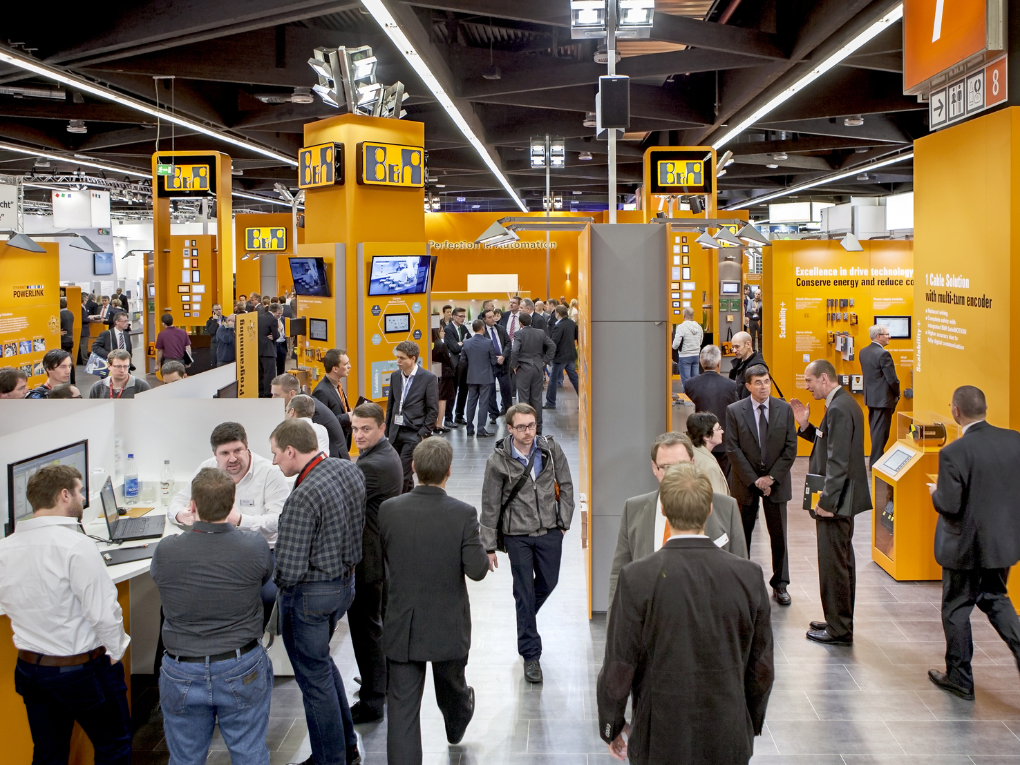
The new mapp View HMI solution is just one of the many innovations showcased by B&R at the SPS IPC Drives trade fair.

About B&R
B&R, a division of ABB Group, is a global leader in industrial automation headquartered in Austria. B&R combines state-of-the-art technology with advanced engineering to provide customers in virtually every industry with complete solutions for machine and factory automation, motion control, HMI and integrated safety technology. With Industrial IoT communication standards including OPC UA, POWERLINK and openSAFETY as well as its Automation Studio software, B&R is constantly redefining the future of automation engineering. The innovative spirit that keeps B&R at the forefront of industrial automation is driven by a commitment to simplifying processes and exceeding customer expectations.
For more information, visit www.br-automation.com.

