The compact S-class controller
New X20 Compact-S controllers available in 5 variants
B&R presents its new Compact-S family of controllers within the X20 system. The new controllers combine 2 previously conflicting characteristics: They are both powerful and compact. Customers can choose between 5 different variants to get the product that best meets the requirements of the machine – technically and economically.
Cycle times between 400 µs and 4 ms
As standard, the new controllers are equipped with USB, POWERLINK and Gigabit Ethernet interfaces and are fully compatible with all other X20 controllers. The most powerful version of the Compact S-controllers achieves cycle times down to 400 µs and has 256 MB of RAM and 2 GB of internal flash memory.
If this performance is not needed, a variant with a maximum cycle time of 800 µs or 1 ms can also be selected. For machines that do not require a real-time network, the two smallest Compact-S variants can be used. They have Fast Ethernet and can achieve cycle times as low as 2 or 4 ms.
Completely scalable
The new controllers have a width of only 37.5 mm, including the power supply, making them the most compact in their class. With POWERLINK, Ethernet, USB and RS232 as standard equipment, they offer ample communication options. A CAN interface is also available as an option without increasing the size. If the application requires additional interfaces, the controller can be modularly expanded by one or two X20 interface slots. This allows the entire product range of X20 fieldbus interfaces to be used.

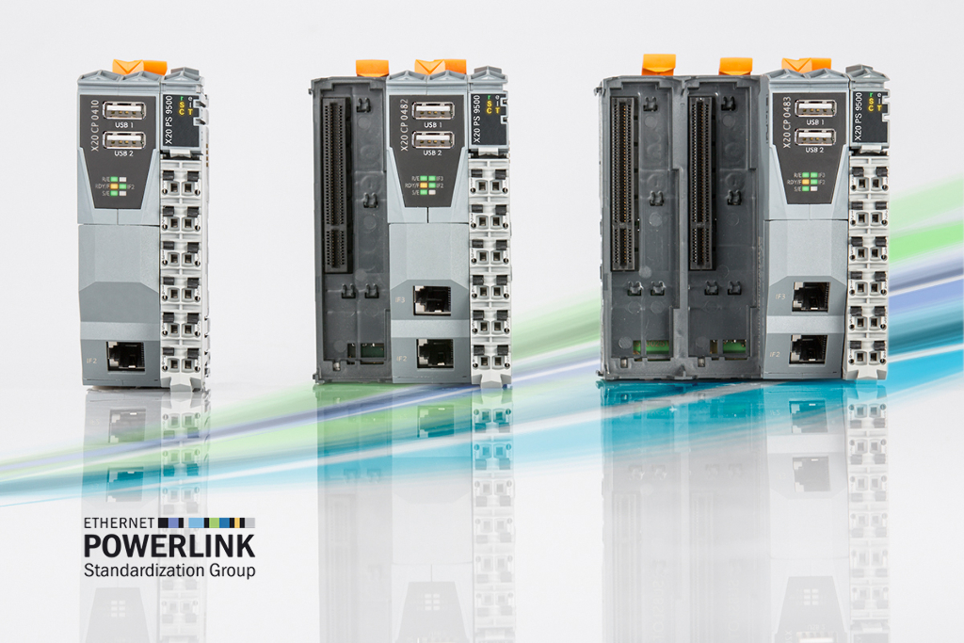
The new compact Compact-S controllers from B&R are modularly expandable and available are in 5 different performance classes.

About B&R
B&R, a division of ABB Group, is a global leader in industrial automation headquartered in Austria. B&R combines state-of-the-art technology with advanced engineering to provide customers in virtually every industry with complete solutions for machine and factory automation, motion control, HMI and integrated safety technology. With Industrial IoT communication standards including OPC UA, POWERLINK and openSAFETY as well as its Automation Studio software, B&R is constantly redefining the future of automation engineering. The innovative spirit that keeps B&R at the forefront of industrial automation is driven by a commitment to simplifying processes and exceeding customer expectations.
For more information, visit www.br-automation.com.

