Utilize braking energy effectively
B&R expands its ACOPOS P3 servo drive series
The new 2-axis modules from B&R's ACOPOS P3 series feed braking energy back into the mains. This function significantly improves the overall effectiveness of a machine. With just 500 watts of regenerative braking power, the function pays for itself in only a year.
A prime candidate for this function are machine tools, whose headstock spindle drives generate large amounts of braking energy that would otherwise go unused. The function is also well suited for conveyor systems that move heavy loads vertically. Without power regeneration, not only would the braking energy go to waste, but the resulting heat would require additional cooling and consume even more power.
Regenerative braking is implemented particularly efficiently in the new 2-axis modules from the ACOPOS P3 series. One of the axes is configured as the feedback path to return excess power to the mains.
Additional functions with ACOPOSmulti
Like the new ACOPOS P3, the active power supply modules from the ACOPOSmulti series also support regenerative braking. These models also offer other helpful functions such as stabilization of the DC bus voltage and compensation of the reactive power.

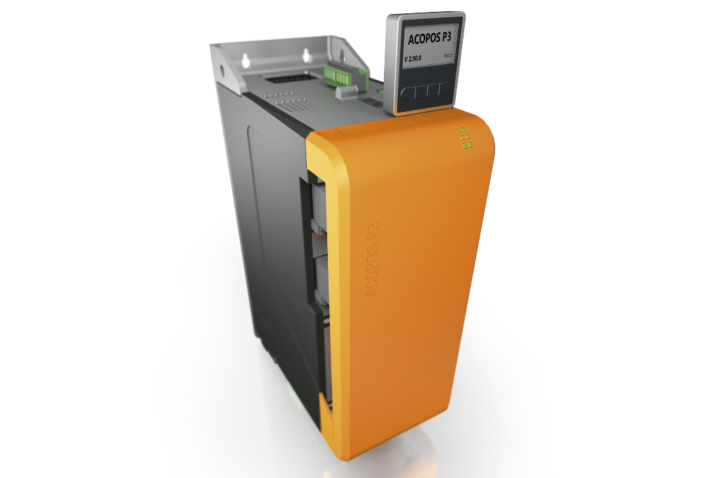
The new 2-axis modules from B&R's ACOPOS P3 series feed braking energy back into the mains. This function significantly improves the overall effectiveness of a machine.

About B&R
B&R, a division of ABB Group, is a global leader in industrial automation headquartered in Austria. B&R combines state-of-the-art technology with advanced engineering to provide customers in virtually every industry with complete solutions for machine and factory automation, motion control, HMI and integrated safety technology. With Industrial IoT communication standards including OPC UA, POWERLINK and openSAFETY as well as its Automation Studio software, B&R is constantly redefining the future of automation engineering. The innovative spirit that keeps B&R at the forefront of industrial automation is driven by a commitment to simplifying processes and exceeding customer expectations.
For more information, visit www.br-automation.com.

