Web-based HMI made easy
mapp View: where web meets automation
With mapp View, B&R now offers direct access to the wide world of web technology right from the engineering environment. Automation engineers have all the tools they need to create powerful and intuitive HMI solutions. There is no need to deal directly with HTML5, CSS and JavaScript technology.
mapp View relies 100% on web standards to ensure content can be viewed optimally on any output device or even customized for specific users or user groups.
Working in a familiar environment
What makes mapp View unique is the way it integrates web technology right into the engineering environment. While mapp View is built on HTML5, CSS3 and JavaScript, automation programmers never need to deal with these languages.
Reusable elements
All GUI functionality is encapsulated in modular control elements called widgets, which are simply dragged and dropped into place and configured. Since content and layout are separated, designs can be adjusted at any time or even used on other machines.

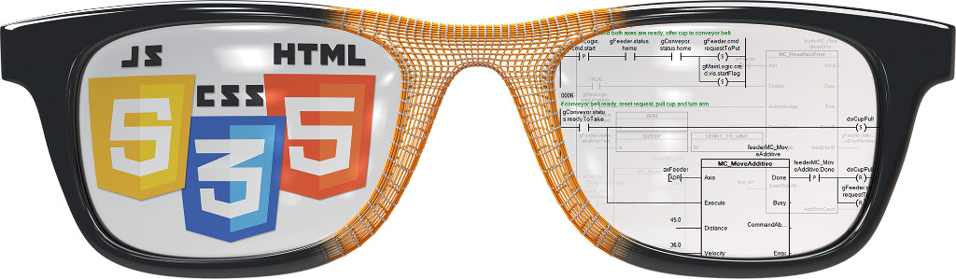
Automation engineers have all the tools they need to create powerful and intuitive HMI solutions.

About B&R
B&R, a division of ABB Group, is a global leader in industrial automation headquartered in Austria. B&R combines state-of-the-art technology with advanced engineering to provide customers in virtually every industry with complete solutions for machine and factory automation, motion control, HMI and integrated safety technology. With Industrial IoT communication standards including OPC UA, POWERLINK and openSAFETY as well as its Automation Studio software, B&R is constantly redefining the future of automation engineering. The innovative spirit that keeps B&R at the forefront of industrial automation is driven by a commitment to simplifying processes and exceeding customer expectations.
For more information, visit www.br-automation.com.

