Network-integrated light curtains save money
New safety concepts with openSAFETY light curtains – thanks to B&R and Datalogic
B&R offers considerable savings in safety applications through network-integrated light curtains. Light curtains equipped with an openSAFETY interface eliminate the hardwiring required for conventional solutions. The company Datalogic is the first to bring these network-integrated light curtains to market.
Single-beam evaluation
An additional advantage of openSAFETY light curtains is the ability to evaluate each beam individually. This makes it possible to implement intelligent muting, for example, doing away with the sensors that were necessary for previous muting solutions.
Easy configuration and diagnostics
With a B&R solution using openSAFETY light curtains, safety functions such as muting and blanking are easily programmed in the Automation Studio development environment. The amount of work needed for commissioning is considerably reduced – especially for equipment produced in series. Diagnostics have also been simplified, with information available in plain text instead of having to be decrypted from LEDs.
openSAFETY implemented by Datalogic
"openSAFETY light curtains allow us to offer our mutual customers a whole new realm of safety solutions," stresses Paolo Zanetta, product manager for safety at Datalogic. "The customer enjoys maximum conceptual design freedom and even saves money compared to applications with simple binary data structures."

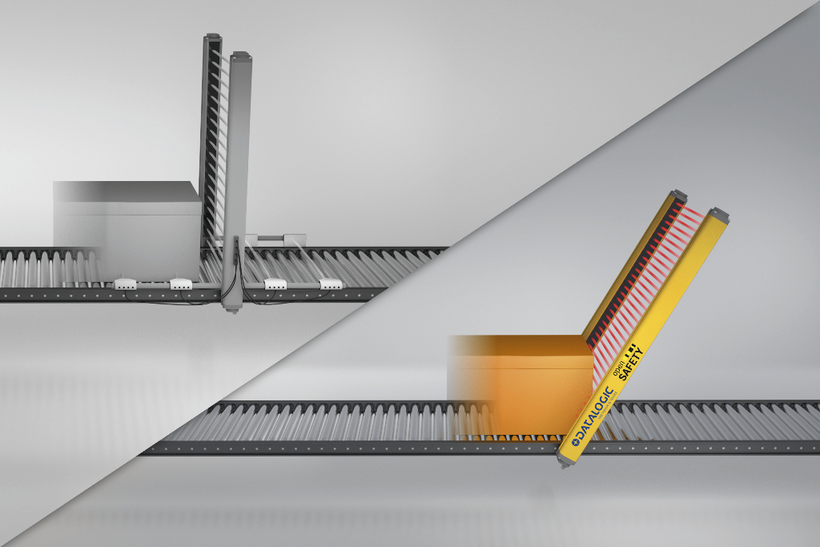
An openSAFETY light curtain mounted at an angle eliminates the need for additional sensors and safe I/O modules. The light curtain is connected directly to the industrial Ethernet network.

About B&R
B&R, a division of ABB Group, is a global leader in industrial automation headquartered in Austria. B&R combines state-of-the-art technology with advanced engineering to provide customers in virtually every industry with complete solutions for machine and factory automation, motion control, HMI and integrated safety technology. With Industrial IoT communication standards including OPC UA, POWERLINK and openSAFETY as well as its Automation Studio software, B&R is constantly redefining the future of automation engineering. The innovative spirit that keeps B&R at the forefront of industrial automation is driven by a commitment to simplifying processes and exceeding customer expectations.
For more information, visit www.br-automation.com.

