OPC UA companion specification for POWERLINK
Further information:
• OPC UA down to the sensor
B&R customers benefit from cooperation between the OPC Foundation and the EPSG
B&R customers will now be able to benefit from integrating communication from the sensor layer to the ERP layer without any interfaces whatsoever. This will be made possible by a companion specification that is now being developed by both the OPC Foundation and the Ethernet POWERLINK Standardization Group (EPSG).
Industry 4.0 and the Internet of Things (IoT) require seamless and consistent communication both within the digital factory as well as externally to cloud-based services and other Internet technologies. These requirements are now being met as the EPSG and OPC Foundation work to implement a common definition for open interfaces between their technologies. B&R has been relying on the open-source POWERLINK protocol for years, so all future B&R automation solutions will allow communication without interfaces.
Leading real-time Ethernet system
"POWERLINK is one of the leading real-time bus systems for machine manufacturers," said OPC Foundation president Thomas J. Burke during the OPC Foundation's press conference at the SPS IPC Drives trade show. It is an excellent complement to the functionality provided by OPC UA, he emphasized. "OPC UA is ideal for connecting directly to real-time networks and allows complete, secure and scalable communication between these networks and the world of IT."
Ideal combination
"The combination of OPC UA and POWERLINK is ideal for integrating devices from different manufacturers as well as the various levels of the automation pyramid to create a complete system," said EPSG managing director Stefan Schönegger. "For this reason, the EPSG relies on OPC UA as the communication protocol from the control level all the way up to ERP systems."

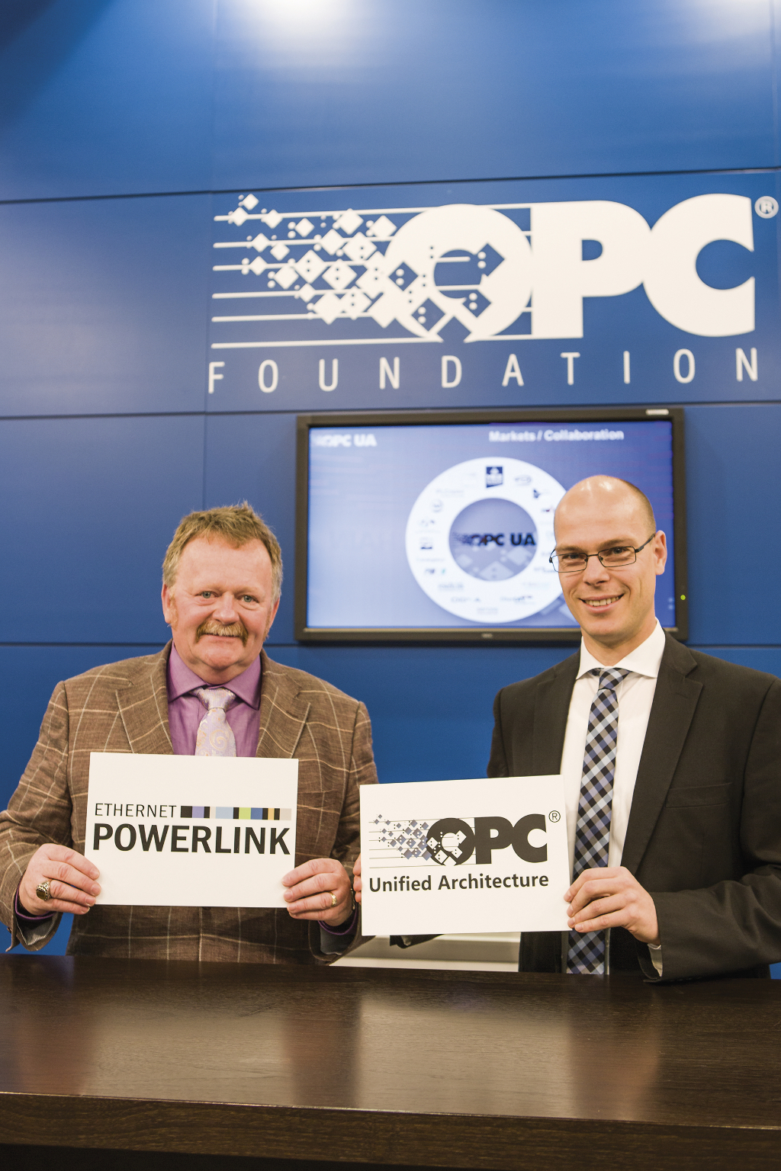
Thomas J. Burke (left), president of the OFC Foundation, and Stefan Schönegger, managing director of the EPSG, announce the development of an OPC UA companion specification for POWERLINK at the SPS IPC Drives trade fair.

About B&R
B&R, a division of ABB Group, is a global leader in industrial automation headquartered in Austria. B&R combines state-of-the-art technology with advanced engineering to provide customers in virtually every industry with complete solutions for machine and factory automation, motion control, HMI and integrated safety technology. With Industrial IoT communication standards including OPC UA, POWERLINK and openSAFETY as well as its Automation Studio software, B&R is constantly redefining the future of automation engineering. The innovative spirit that keeps B&R at the forefront of industrial automation is driven by a commitment to simplifying processes and exceeding customer expectations.
For more information, visit www.br-automation.com.

