All in one system
COMAU and B&R assimilate robotics into machine control
With the introduction of openROBOTICS, partners COMAU and B&R are opening up new dimensions of robotics integration for machinery and production lines. The solution is based on a full lineup of COMAU robots that handle payloads ranging from 3 to 650 kilograms.
"With completely uniform programming for every component in the line – including the robotics – our customers around the world gain the full benefit of holistic approaches to operation, diagnostics and maintenance," says Tobias Daniel, head of sales and marketing at COMAU Robotics. "You won't find another solution like this on the market." Traditionally, robotics and machinery have always relied on separate controllers or gateways.
Perfectly synchronized
COMAU robots all over the world can now be completely and seamlessly integrated into machines and production lines equipped with B&R automation components. "The customer simply selects the desired COMAU robot in the Automation Studio engineering environment," explains Walter Burgstaller, B&R's European sales director. "With mapp technology, the robot can then be effortlessly incorporated in – and perfectly synchronized with – the machine's automation software. Conventional solutions with cumbersome interfaces will never achieve this kind of usability and performance."

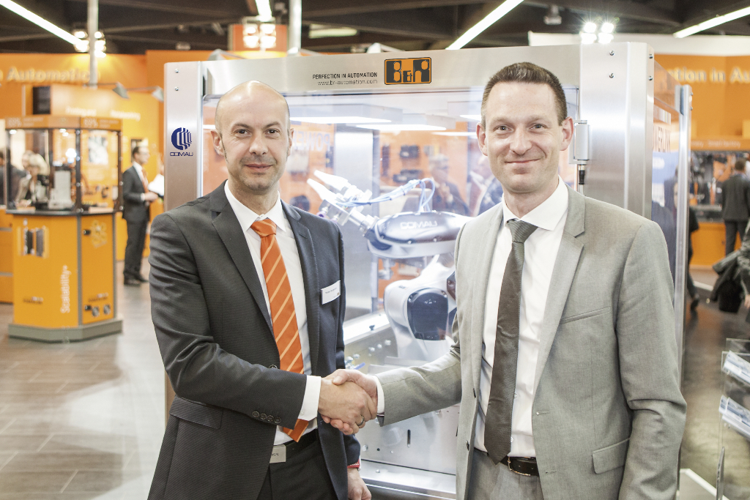
Walter Burgstaller (Sales Director - Europe at B&R, left) and Tobias Daniel (Head of Sales & Marketing at COMAU Robotics) presented openROBOTICS for the first time at SPS IPC Drives 2015.

About B&R
B&R, a division of ABB Group, is a global leader in industrial automation headquartered in Austria. B&R combines state-of-the-art technology with advanced engineering to provide customers in virtually every industry with complete solutions for machine and factory automation, motion control, HMI and integrated safety technology. With Industrial IoT communication standards including OPC UA, POWERLINK and openSAFETY as well as its Automation Studio software, B&R is constantly redefining the future of automation engineering. The innovative spirit that keeps B&R at the forefront of industrial automation is driven by a commitment to simplifying processes and exceeding customer expectations.
For more information, visit www.br-automation.com.

