The future of mobile automation
B&R presents: The modular X90 control and I/O system
B&R continues to open up new possibilities in mobile automation with its innovative X90 product line for mastering mobile control and I/O tasks. The comprehensive set of standardized components is perfect for implementing flexible automation concepts.
The heart of the X90 system is a controller with a powerful ARM processor and 48 multifunction I/O channels. Basic features include interfaces for CAN, Ethernet and the real-time POWERLINK bus system.
Maximum flexibility
The extremely robust cast aluminum housing provides space for up to four expansion cards. These can add additional I/O channels, interfaces and even a full-fledged safety controller with safe I/O. Additional expansion cards for USB, WLAN, Bluetooth and GPS interfaces are in planning.
Maximum protection
All products in the X90 family are designed for use in harsh industrial environments. They can handle operating temperatures from -40 to 85°C as well as strong vibrations or shocks in addition to being resistant to salt, UV light and oil.
Maximum integration
The X90 system offers all of the advantages offered by B&R automation technology. This includes modular and hardware-independent software development using modular software blocks, which greatly reduce software development times and ensure software reusability. Safety technology and extensive troubleshooting options are also fully integrated in the B&R system and available to X90 users without limitations.

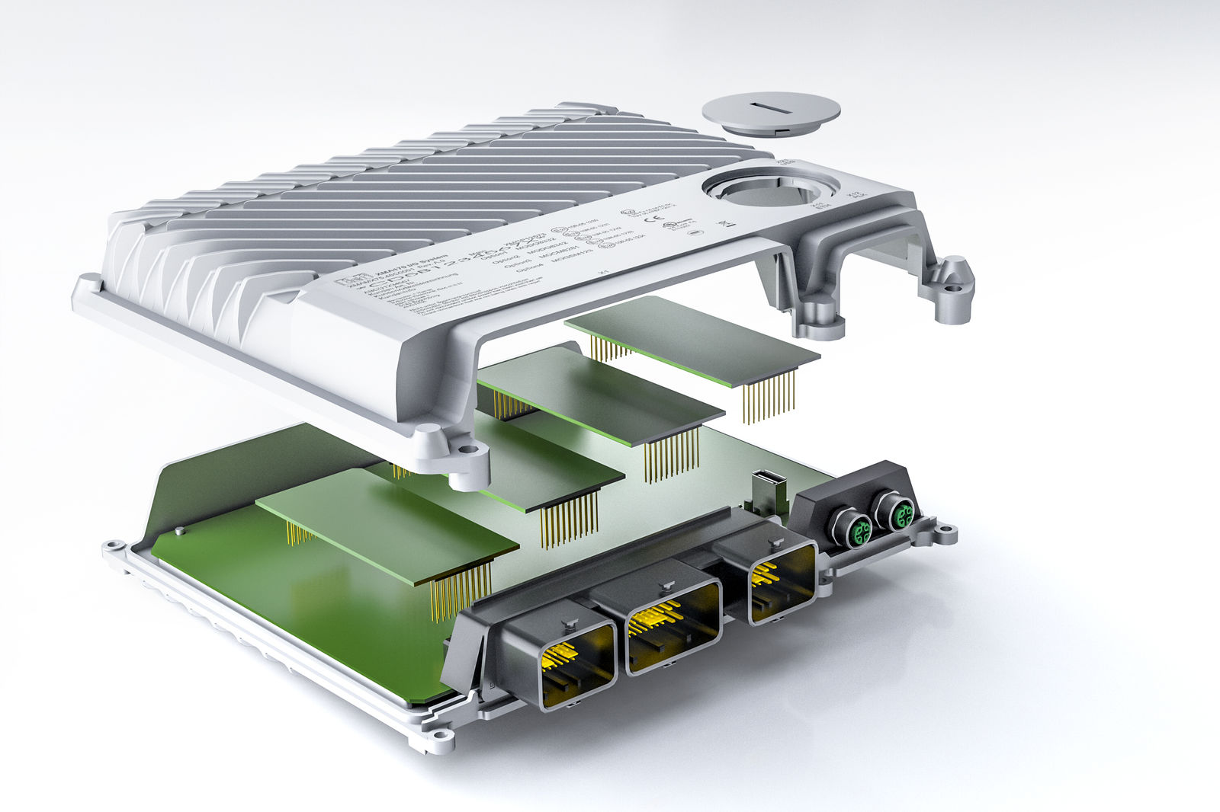
Expansion cards allow the modular X90 control and I/O system to be perfectly tailored to any application.

About B&R
B&R, a division of ABB Group, is a global leader in industrial automation headquartered in Austria. B&R combines state-of-the-art technology with advanced engineering to provide customers in virtually every industry with complete solutions for machine and factory automation, motion control, HMI and integrated safety technology. With Industrial IoT communication standards including OPC UA, POWERLINK and openSAFETY as well as its Automation Studio software, B&R is constantly redefining the future of automation engineering. The innovative spirit that keeps B&R at the forefront of industrial automation is driven by a commitment to simplifying processes and exceeding customer expectations.
For more information, visit www.br-automation.com.

