Glass touch screen as standard
B&R presents new multi-touch terminals
B&R has added an operator terminal with a glass screen and multi-touch technology to its Power Panel T-Series. The new Power Panel T50 is available in widescreen variants with a diagonal of up to 10.1" diagonal and is equipped with a gigabit-capable Ethernet interface.
Compact and versatile
With the new Power Panel T50, B&R offers a modern operator terminal with glass touch screen for web-based or VNC-based HMI. The multi-touch technology also makes it possible to integrate gestures like zooming and swiping. Integrated edge protection safeguards the glass front during harsh everyday operation. The shallow installation depth makes the devices easy to mount in either a control cabinet or swing arm system.
Easy configuration
The Power Panel T50 comes with an integrated service page that opens without having to be installed and offers custom settings such as IP address, DHCP server, screen saver and much more. This configuration can easily be saved on a USB flash drive and copied to other Power Panel T50 devices.

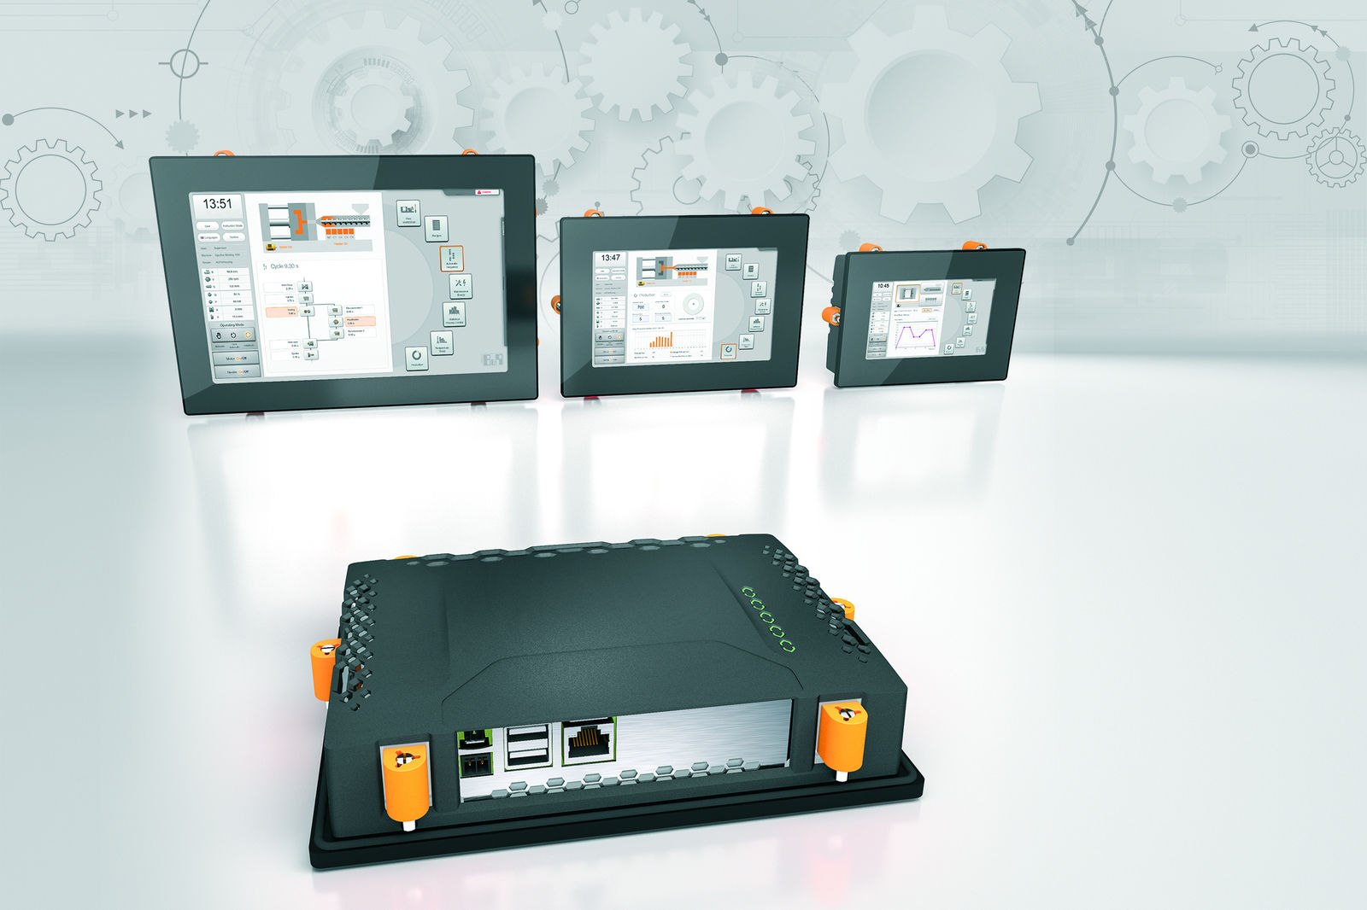
The new Power Panel T50 terminal is compact, easy to configure and ideally suited for premium machine designs.

About B&R
B&R, a division of ABB Group, is a global leader in industrial automation headquartered in Austria. B&R combines state-of-the-art technology with advanced engineering to provide customers in virtually every industry with complete solutions for machine and factory automation, motion control, HMI and integrated safety technology. With Industrial IoT communication standards including OPC UA, POWERLINK and openSAFETY as well as its Automation Studio software, B&R is constantly redefining the future of automation engineering. The innovative spirit that keeps B&R at the forefront of industrial automation is driven by a commitment to simplifying processes and exceeding customer expectations.
For more information, visit www.br-automation.com.

